北京 BEIJING

北京美食 Famous food in Beijing

The food of Beijing ranges from spectacular imperial dishes to comforting home-style dishes. In this ancient capital and the biggest city in China, you can absolutely find some tasty local dishes. They are usually made with dainty materials and fine procedures. Here we would like to introduce the famous food in Beijing.

北京的美食包括曾经的皇家菜肴和舒适的家常菜肴。北京作为古都，又是中国最

大的城市，你绝对可以在北京品尝到美味的当地菜肴。北京的美食通常采用精选

食料，结合精细厨艺制成。下面将为大家介绍北京著名美食。

Peking Roast Duck(Beijing kaoya)
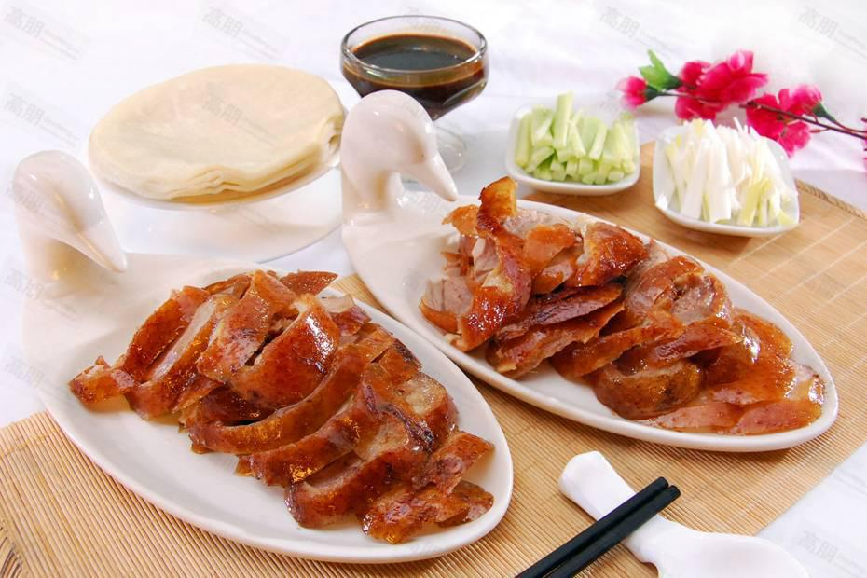

Peking Roast Duck is a must-try food in Beijing. The dish is well-known for its tempting shining color, crispy skin and tender meat. The whole

roast duck will be placed in front of guests and sliced into pieces by the chef. The sliced meat will be eaten together with pancakes, cucumber, spring onion and a sweet bean sauce.

北京烤鸭是一道不容错过的美食。这道菜以其诱人的闪亮色彩，脆皮和嫩肉而闻

名。整个烤鸭将放在客人面前，再由主厨把肉从烤鸭身上片下。切好的肉可与薄

煎饼，黄瓜，葱和甜豆酱一起食用。

Zhajiang Noodles(Zhajiang mian)
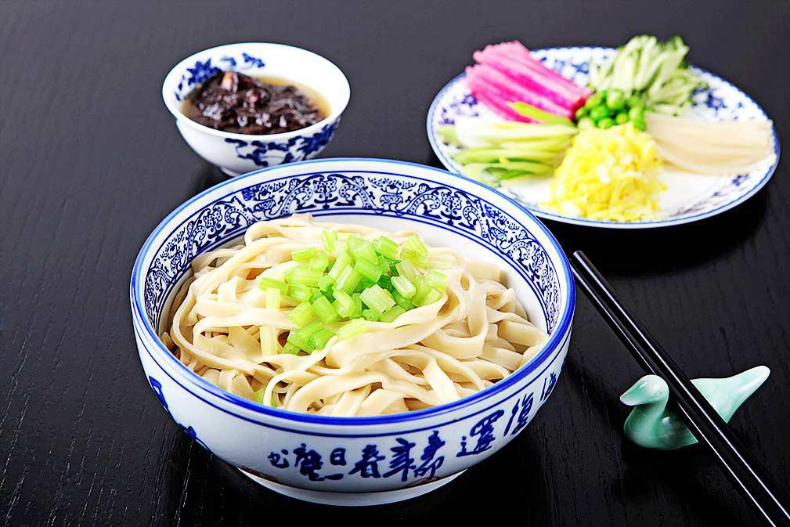

Zhajiang Noodles, or Zhajiang mian, is a popular noodle dish in Beijing. The dish is made with hand-pulled wheat noodles served with shredded cucumber bean sprouts, bright radish, and soybeans and bean sauce.

炸酱面是北京最受欢迎的面条。这道菜是用手拉的小麦面条制成的，配上切碎的黄瓜豆芽，鲜萝卜，大豆和豆沙一起食用。

Instant Boiled Mutton(Shuan yangrou)

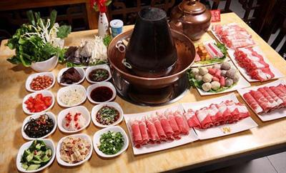

Instant Boiled Mutton is a famous Beijing hotpot dish which dates back to the Yuan Dynasty and it is different from hot pot in other areas since mutton is the only main meat used in the dish. Sliced mutton will be put in a hotpot and boiled in soup. It is usually served with sesame sauce, preserved bean curd, leek flower and sliced spring onion.

涮羊肉是一种流行于北京及其周边地区的传统美食，可追溯至元代。涮羊肉不同

于一般火锅，因食材主要以羊肉为主，故而得名涮羊肉。，可以追溯到元朝。将

切好的羊肉放入火锅中煮好，通常配芝麻酱，腌制豆腐，韭菜花和切片的葱食用。

Mung Bean Milk (Douzhier)
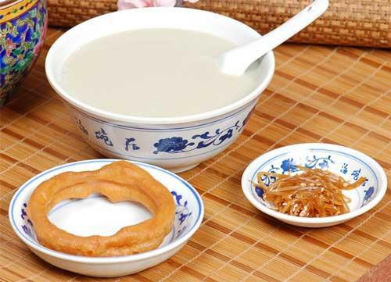

Mung bean milk is actually a by-product while making Mung bean starch or noodles. It is a traditional soup with a distinctive flavor in Beijing. The soup is grayish green, mellow, sour and slightly sweet. Local Beijing citizens have a special preference for it. But some people don’t like it either due to the sour smell.

豆汁儿其实是制作绿豆淀粉或面条的副产品。这是一种风味独特的传统汤。汤是灰绿色，醇厚，酸，微甜。当地的北京市民特别喜欢它。但是有些人不喜欢它，因为它闻起来很酸。

Filled sausage(Guanchang)
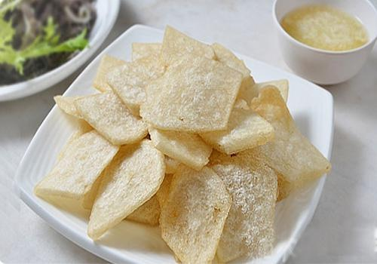

Guan Chang (or Filled sausage) is a popular snack for native Beijing people. Flour or starch is mixed with some spices and then stuffed into prepared pigs’ intestines. The sausage is then boiled and cut into pieces to be fried. It usually served with mashed garlic sauce.

炸灌肠是北京本地人的热门小吃。将面粉或淀粉与一些香料混合，塞入备好的猪肠中。然后将香肠煮沸并切成片以进行煎炸。它通常配有捣碎的蒜酱。

Bao Du
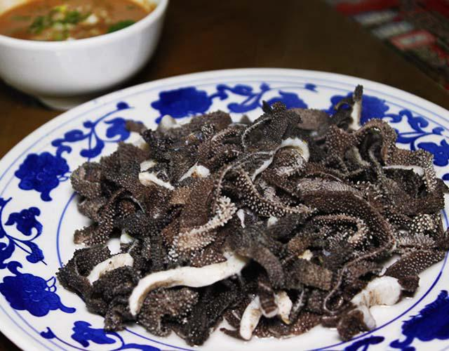

Bao Du (Boiled Lamb Tripe) is a famous local snack in Beijing. This halal food is made of lamb tripe. Fresh lamb tripe is cleaned, cut into pieces and then cooked in boiling water or fried. It is often served with sesame sauce, vinegar, chili oil, soy sauce, spring onion and other seasonings.

爆肚（煮熟的羊肚）是北京着名的本地小吃。这种清真食物由羊肚制成。将新鲜的羊肚切成小块，切成片，根据制作方法有水煮、油炸等。它通常配芝麻酱，醋，辣椒油，酱油，葱和其他调味料一起食用。

Rolling Donkey(Lv da gun)
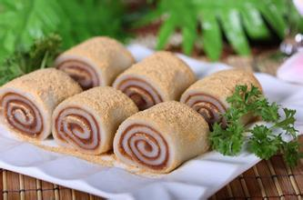

As one of the old special Beijing street food in this city, it is sweet and glutinous with a strong taste of soybean flour. The ingredients include rhubarb rice flour, sweetened bean paste, white sugar, sesame oil, sweet osmanthus and nuts. Literally, the Chinese name means a donkey rolls on the ground, which vividly describes the process of rolling the stuffed rolls in bean flour.

驴打滚是特色北京街头美食之一，它的味道甜美，糯米味道浓郁。成分包括大黄

米粉，甜豆沙，白糖，芝麻油，桂花和坚果。从字面上看，中文名字意味着驴在

地上滚动，生动地描述了在豆粉中滚动馅卷的过程。

Fried-pouch Roll(Dalian huoshao)
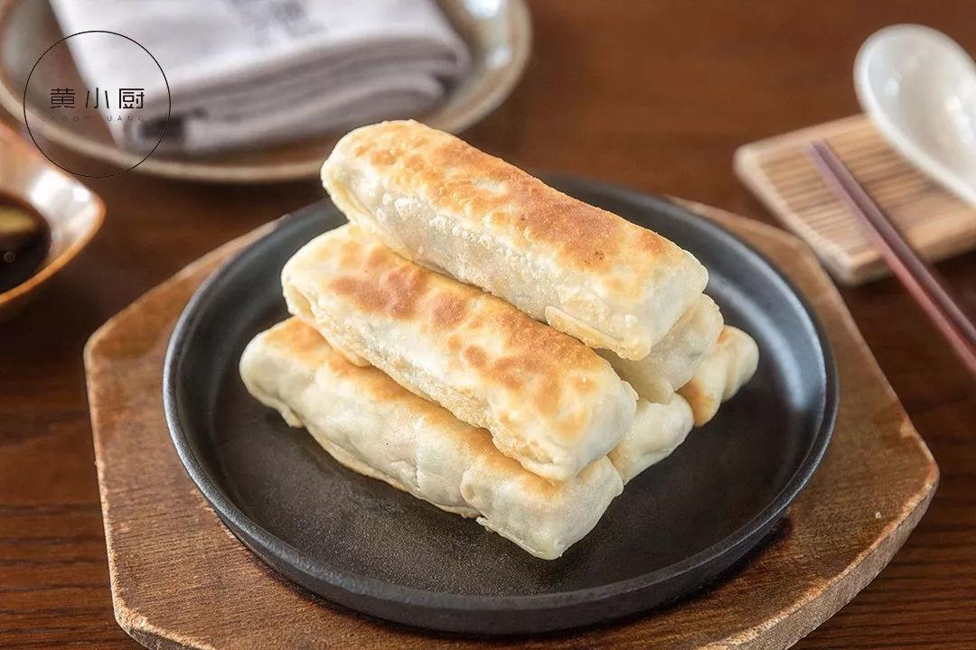

It is a pouch-shaped crispy-skinned roll filled with different fillings, including traditional taste of pork with scallion, pork with leek and pork with fennel, etc. Its Chinese name means pouch in the ancient China due to the shape of the food. It is one of a popular Beijing street food in this city with cheap price. If you like pan-fried dumplings, you might also love this.

褡裢火烧是一个袋状的脆皮卷，里面装满了不同的馅料，通常有猪肉和葱的传统口味，韭菜猪肉和茴香猪肉等。食物形状因似古时的褡裢因而得名。与价格合理，是北京最受欢迎的小吃之一。如果你喜欢煎饺，你可能也喜欢这个。

Tanghulu
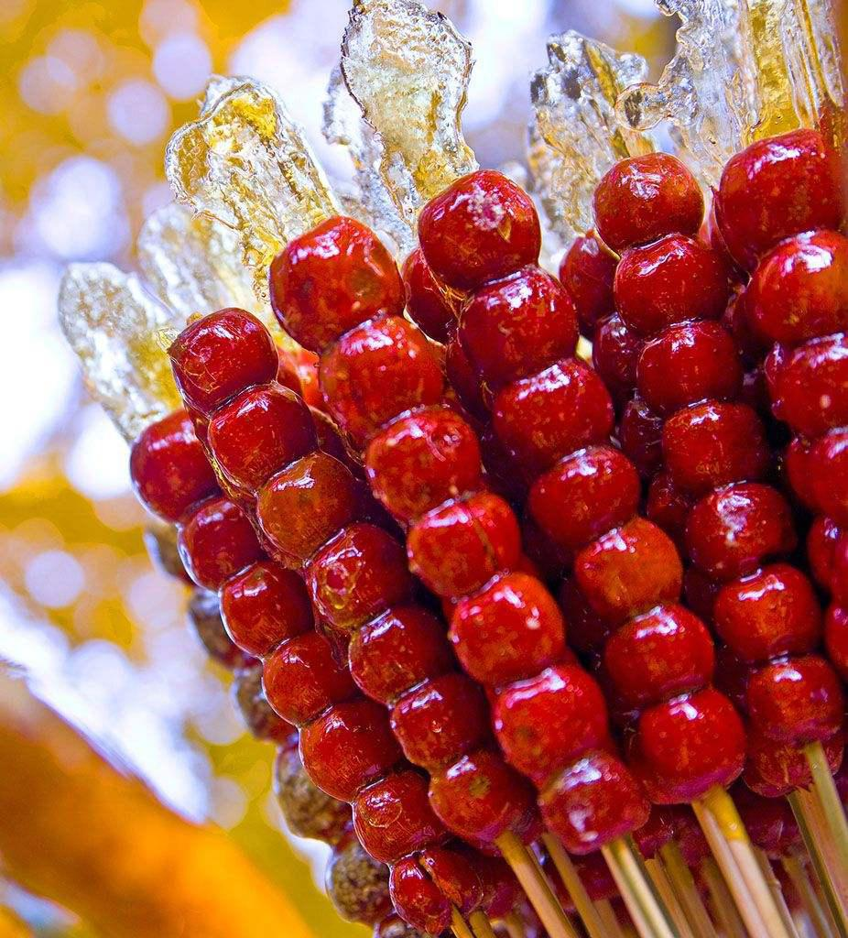

Tanghulu also called bingtanghulu, is a traditional Chinese snack of candied Crataegus pinnatifida, also known as mountain hawthorn or Chinese haw. Coated in sugary hardened syrup, tasted sweet and sour, tanghulu is a very popular treat in Northern China.

糖葫芦又叫冰糖葫芦，是由蜜饯山楂制成的中国传统小吃。糖葫芦的表层包裹着糖浆，味道酸甜，在北方地区非常流行。

颐和园 The Summer Palace

Natural Features 自然概况

The Summer Palace is located on the western edge of Beijing， between the fourth and fifth ring roads ，close to the western hills，10km from central Beijing 一 It is the largest and best-preserved imperial garden in

China. Its Chinese name ， Yi He Yuan ， translates as‘Garden for Maintaining Health and Harmony'.

颐和园位于北京西郊，在四环和五环之问，紧挨西山，趾北京市中心 12 公里〕颐和园是中国最大的空家园林。其汉语意思为“颐养和谐之园”。
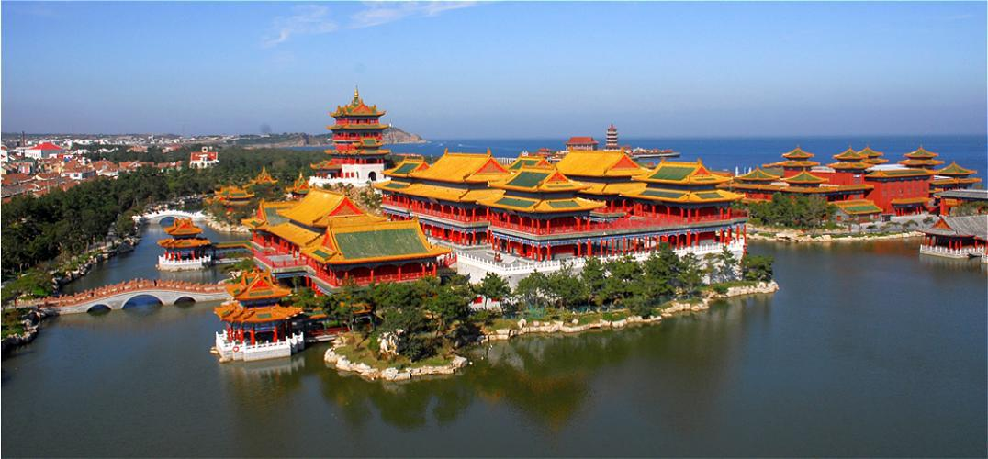

As its name implies，the Summer Palace was used as a summer residence by China's imperial rulers--as a retreat from the main imperial palace now known as the Palace Museum or Forbidden City-a pleasureground in the countryside，yet near to the city.

颐和园的英文名称"Summer Palace”（夏天的宫殿)意思是这里是皇帝在夏大的居住之地—一个离城不远、位与乡村的、供帝王后妃们逍遥游乐的紫禁城。

The gardens that became the Summer Palace date from the Jin Dynasty (1115 一 1234 ).Later, the Mongol Emperor Kublai Khan(Yuan Dynasty，1279-1368)，who wanted to improve Beijing's water supply，ordered the construction of canals to transport water from the Western Hills to the Summer Palace. He also enlarged the lake(today's Kun Ming Lake)to act as a reservoir.

早在金代( 1115 一 1234 ）,颐和园就已经开始成为花园随后，元朝(1279~1368)的忽必烈又改进北京的水系统，开挖运河把西山的水引到颐和园，他还扩建了昆明湖作为蓄水池。

In 1750，Emperor Qian Long(1736 一 1796 )of the Qing Dynasty(1644 一 1911) added substantially to the gardens of the Summer Palace. His

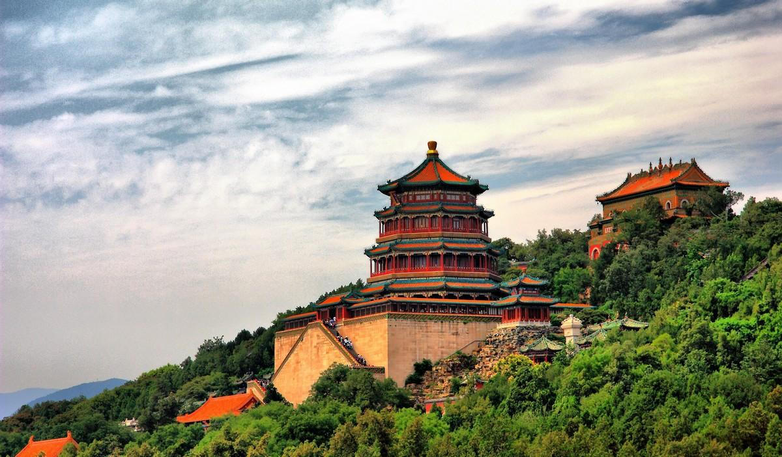

appointed designers reproduced the styles of various palaces and gardens from around China. Kun Ming Lake was extended to imitate the West Lake in Hangzhou.

1750 年，清朝(1644-1911)的乾隆皇帝再接再厉，把这个花园修建成了皇家园林。他让设计师们复制中国的各种园林风格汇集于此。昆明湖就是模仿杭州西湖而造的。

In 1860，the Anglo-French Allied Forces invaded Beijing and set fire to many of the buildings within the Summer Palace.

1860 年，英法联军浸略北京，纵火烧毁了这里的大部分建筑。

In 1886,Dowager Empress Ci Xi，with embezzled funds from the Imperial Navy，restored the grand gardens. The reconstruction and enlargement of the Summer Palace continued for ten years. After completion,she renamed the gardens‘Yi He Yuan'(Garden of Peace andHarmony)

1886 年，慈嬉太后挪用海军经费重建并扩建了这些花园，工程持续 10 年之久，完 1 年后她将其改名为颐和园(颐养和谐之园)。

In 1889 ， the Empress Dowager Ci Xi moved her administration to the renovated Yi He Yuan and the gardens that had long been an imperial pleasure ground became the primary Summer Palace.

1889 年，慈嬉连同她的行政部门一起搬到修复一新的颐和园。从此，颐和园变成了首要的皇家夏日游乐场所。

- full-scale restoration began in 1903 ， and today's Summer Palace is more or less the same as the palace rebuilt from then.

1903 年，慈嬉逃亡返回北京后，又对颐和园做了全方位的修复今天的颐和园与修复后的颐和园大致相似。

After the success of the 1911 Revolution ， the Summer Palace was opened to the public. Then，after the last Qing Emperor Pu Yi was thrown out of the Palaces in 1924，the Summer Palace was turned into a park. The Summer Palace has become a popular and relaxing destination for both domestic and international tourists now.

1911 年革命成功后，颐和园开始对一外开放。不过，颐和园成为真正的公园是

1924 年清朝的末代空帝被赶出官殿之后。如今，颐和园已成为中外游人喜欢游玩的好去处。 The Summer Palace was designated a World Heritage site by UNESCO in 1998. 1998 年，颐和园被联合国教科义组织列人《世界遗产名

录》。
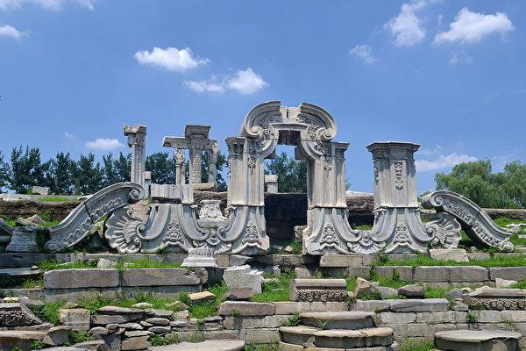

The palace is the largest and the best-preserved royal garden in the world with the richest cultural connotation,hence it is honored as a the museum of royal gardens. Its general layout makes full use of the hill and the lake，together with the borrowed views from the peaks of the west mountain，which brings about infinite scenery variations with exceeding beauty. The buildings in the palace are the architectural cream from all parts of China. The administrative and residential areas in the east of the palace are typical of the quadrangle in northern China ， where the enclosed courtyards are connected by various roofed causeways. The lake area in its south ， however ， is an imitation of West Lake of Hangzhou ， where a dyke divides the lake in two ， thus giving it an obvious touch of southern China landscape. On the north side of Longevity Hill，the scene is that of Tibetan masery，where stand white pagodas and buildings like blockhouses And in north ， the Suzhou Market Street，with all kinds of shops and its crisscrossing water courses， is again in the style of the waterscape in southern China. “

颐和园是世界上建筑规模最大，保存最完整，文化内涵最丰富的皇家御苑，被誉

为皇家园林博物馆。全园以山湖形式巧做安排，以西山群峰借景，使园内景色变

幻无穷，美不胜收园内建筑吸收了中国各地建筑的精华。东部的宫殿区和内廷区，

是典型的北方四合院风格。一个个封闭的院落山游廊连通;南部的湖泊区是仿杭州西湖景色，一道西堤把湖泊一分为二，具有一浓郁的江南情调;万寿山的北面，是典型的西藏喇嘛庙宇风格，有白塔及城堡式建筑，北部的苏州街，店铺林立，水道纵横，又是典型的江南水乡风格。

Major Scenic Sites 主要景点

Hall of Benevolence and Longevity Area 仁寿殿景区

East Palace Gate 东宫门 Hall of Benevolence and Longevity 仁寿殿 Hall

of Jade Billows 玉澜堂 Hall of Joyful Longevity 乐寿堂 Garden of Virtue

and Harmony 德和园

Kunming Lake Area 昆明湖景区

Kunming Lake 昆 明 湖 Pavilion of Flourishing Culture 文 昌 阁 Seventeen-arch Bridge 十·七孔桥 Pavilion of Broad View 廓如亭 Penglai Isle:Shrine for Universal Blessing Rain 蓬莱岛:广润灵雨祠 Six Bridges of West Dyke:Tower of Bright Scene 西堤六桥:景明楼

Long Gallery Area 长廊景区

Long Gallery 长廊 Hall of Oriole Singing 听鹂馆 Clear and Calm Boat 清晏舫

Longevity Hill Area 万寿山景区

Hall of Dispelling Clouds 排云殿 Tower of Buddhist Incense 佛香阁 Prayer Wheel Repository 转轮藏 Treasure Cloud Pavilion 宝云阁 Sea of

Wisdom 智 慧 海 Pavilion of Great Happiness 景 福 阁 Garden of Harmonious Interests 谐 趣 园 Rambling in Picture 画 中 游 Four Continents 四大部洲 Suzhou Market Street 苏州街

Other Attractions Around the Place 周边名胜

Beijing arboretum 北京植物园 Fragrant Hills 香山

Yuanmingyuan Park 圆明园

故宫（紫禁城）The Forbidden City

北京是一座千年古都，其建筑布局保留着最典型的中国古代城市特征：方正的、围绕一个中心点呈环型分布。每一个初到北京的人对这里笔直的大马路都会有一种强烈的感觉，而当你从高空俯瞰北京城时，就能更深切地体会到它的雍容华贵。
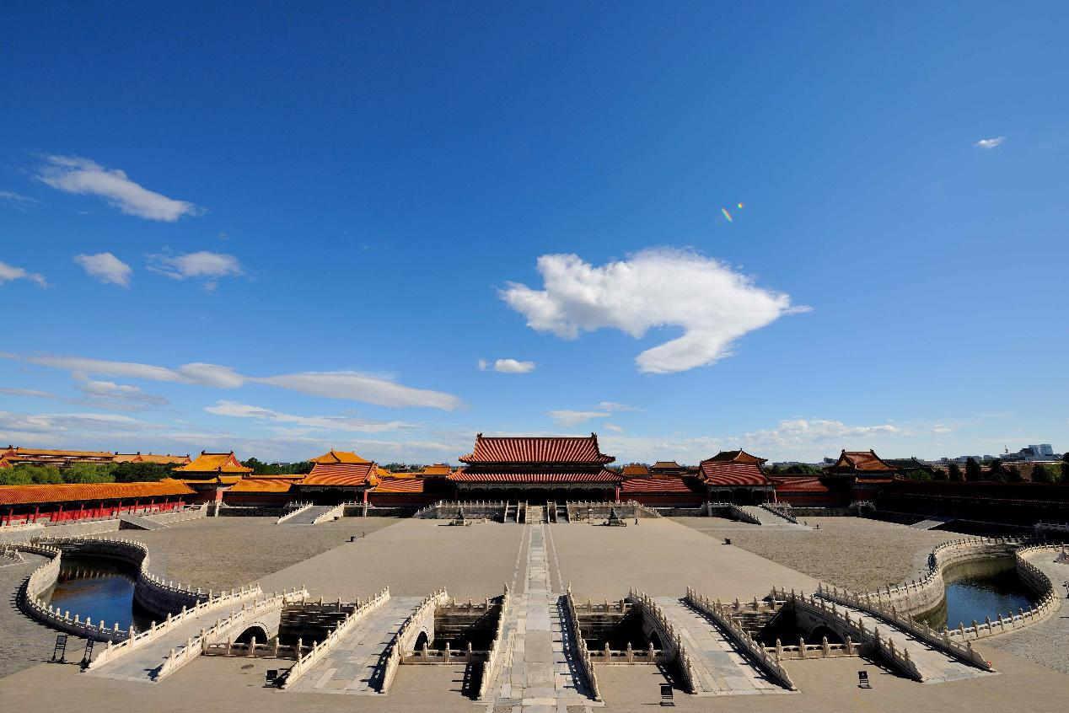

位于城市中心的就是著名的紫禁城——故宫，整个城市以一条自南而北长达 7.5

公里的中轴线为骨干，这条中轴线从永定门开始经正阳门到天安门，从天安门往北，进入紫禁城，从神武门出皇宫便是皇家园林景山，后到地安门，最后到钟楼、

鼓楼。在这条线南端 两侧修有天坛和先农坛，中部两侧有太庙和社稷坛。
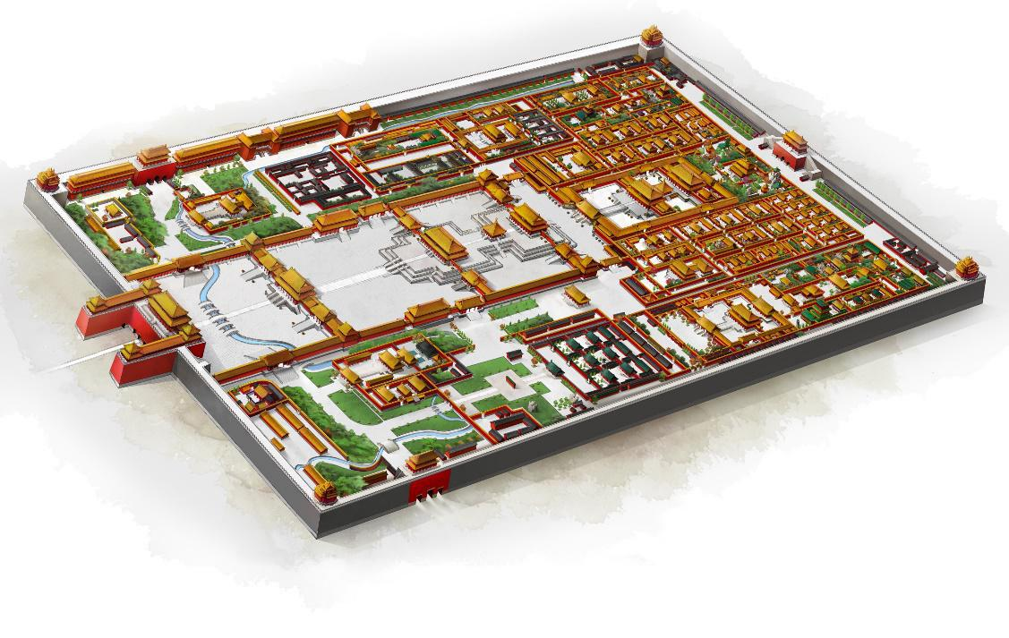

北京的现代城市建设也基本依照这一原则，虽然有了五条环路，但城市中心仍然未变。
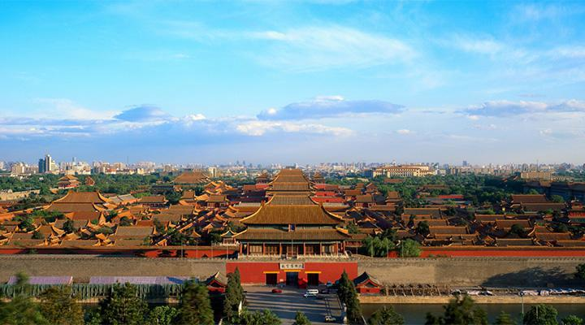

Beijing is an ancient capital. Its construction and layout retains the most typical characteristics of old Chinese cities, including a square shape with a core fanning out outwards. Everyone arriving in Beijing will have a strong feeling about the straight roads, and when looking over the city

from the air one can see this characteristic even more clearly.
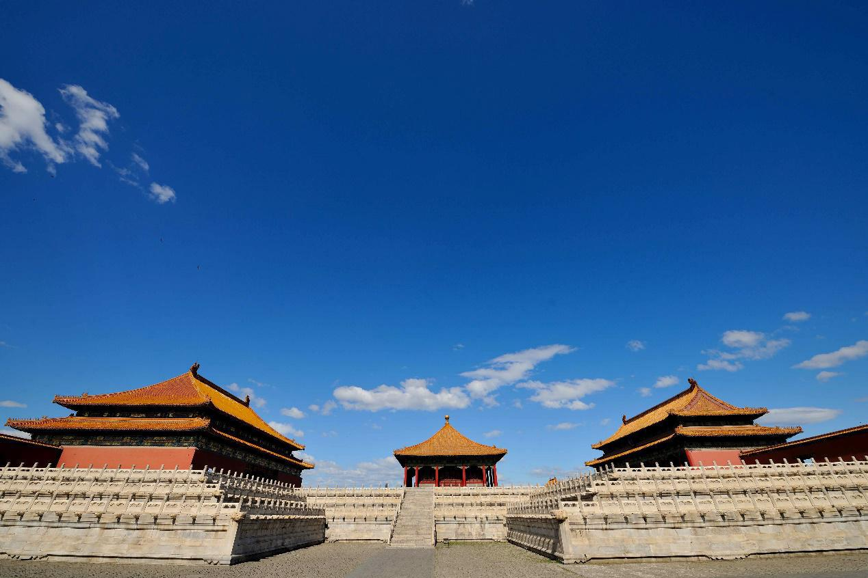

In the centre of the city is Gugong, the famous Forbidden City. The backbone of the whole city is a central north-south axis 7.5 km in length. This axis begins from the Yongding Gate via Zhengyang Gate to the Tiananmen Square, then from Tiananmen to the north into the Forbidden City, (outside of which via the Shenwu Gate is the royal garden Jingshan Mount), then to the Di’an Gate, and finally to the Zhonglou (the clock tower) and Gulou (the drum tower). The Temple of Heaven and the Altar of the God of Agriculture are at the southern end, while the Imperial Ancestral Temple and the Altar of Land and Grain are built on the both sides of the middle. Beijing's modern urban construction is basically in accordance with this principle, and although there are five loops, the city centre is still unchanged.

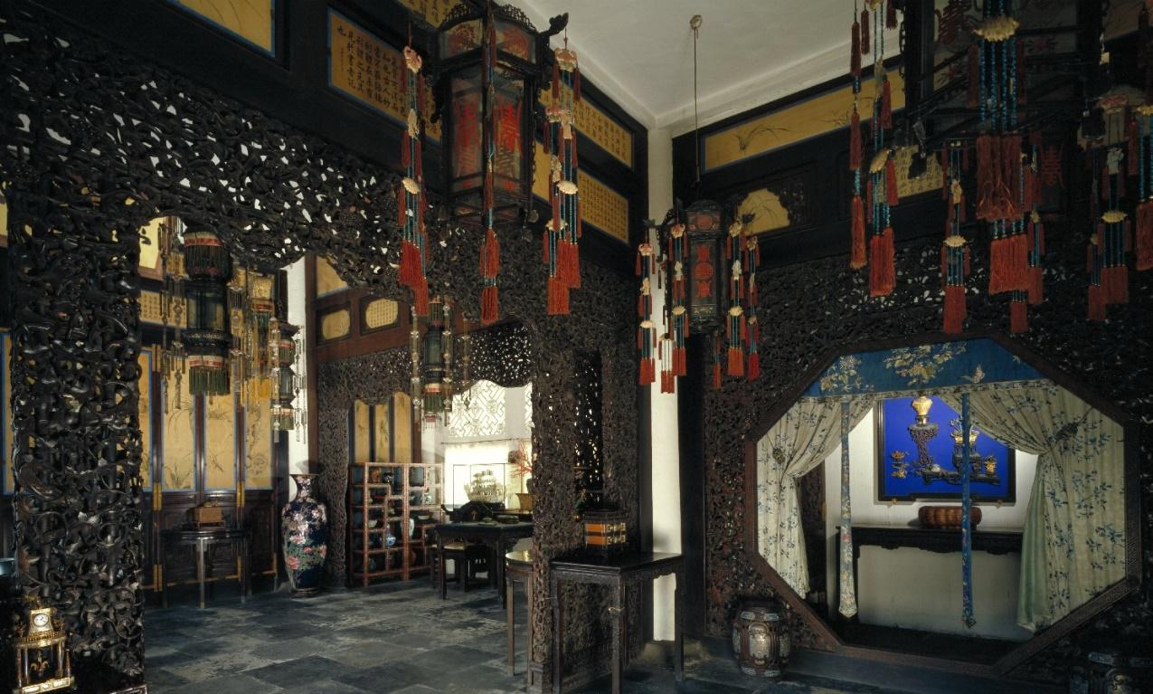

八达岭长城 Badaling Great Wall

长城，又称万里长城，是中国古代的军事防御工程，以保护中国各地免受欧

亚草原各游牧群体的袭击和入侵。早在公元前 7 世纪就建造了一些城墙;后来这

些城墙被联接起来统称为长城。其中有名的是中国第一位皇帝秦始皇于公元前

220-206 年建造的城墙，至今只有很有一部分存世。长城在各个朝代都得到了

重建维护和增强;现存的大部分城墙都是明朝（1368-1644）时重建的。北京八

达岭长城是保存最完整，最完整的一部分长城。

The Great Wall, also known as the Wàn-Lǐ Great Wall, is a military defense project in ancient China to protect the Chinese states and empires against the raids and invasions of the various nomadic groups of the Eurasian Steppe. Several walls were being built as early as the 7th century BC; these walls later joined together ， which are collectively referred to as the Great Wall. Especially famous is the wall built in 220– 206 BC by Qin Shi Huang, the first Emperor of China. Little of that wall remains. The Great Wall has been rebuilt, maintained, and enhanced over various dynasties; the majority of the existing wall is from the Ming

Dynasty (1368 – 1644). Badaling Great Wall in Beijing is the best-preserved and most complete section.
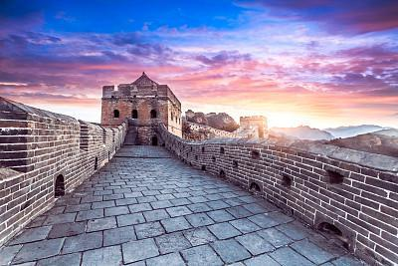

八达岭长城位于北京市中心

西北约 43 英里（70 公里）处。

这一段的总长度为 7.5 英里（12

公里），有 43 个瞭望塔。但只有

2.3 英里（3.74 公里）的城墙和

- 个瞭望塔已经修复并向游客开

放。八达岭长城的墙壁平均高约 26 英尺（7.8 米），宽 20 英尺（6 米），可允许

五匹马同时疾驰或十名士兵并排前进。

Badaling Great Wall is about 43 miles (70 kilometers)northwest of central Beijing. The total length of this section is 7.5 miles (12 kilometers) with 43 watchtowers, however only 2.3 miles (3.74 kilometers) and 19 watchtowers have been restored and opened to visitors. In this section the wall averages about 26 feet (7.8 meters) tall, and 20 feet (6 meters) wide, which would allow five horses to gallop or ten soldiers to march abreast.

它由巨大的石块和砖块构成。为了稳固城墙，其内部填满了夯土和小石头。墙上还有许多洞用来射箭和观察敌人。瞭望塔是为了让士兵休息，发送消息，观察敌人和储存物资而建造的。

It is built of huge bar-stones and bricks. The interior of the wall was stuffed with rammed earth and small stones to make it firm and solid. A number of holes have been drilled in the wall to shoot arrows and to watch enemies.The watchtowers were built to accommodate soldiers, send messages, observe the enemy, and store supplies.
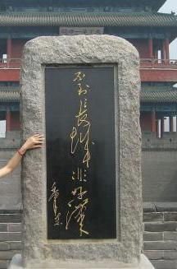

这里有一块石碑，上面刻着“不到长城非好汉”，

是毛泽东一首诗歌中的名言，意思是“He Who Has

Never Been to the Great Wall Is Not a True Man”。八达岭长城的最高点叫做“好汉坡”（Hǎohàn Pō）。

This section has a stone engraved with "不到长城非好汉", a famous line from one of Mao Zedong's poems.It means "He Who Has Never Been to the Great Wall Is Not a True Man". The highest point of this section is called 'Good Man Slope' (好汉坡 Hǎohàn Pō).

1987 年 12 月，长城被联合国教科文组织列入世界遗产名录。它吸引了数以千万计的海内外游客。370 多名外国领导人和名人来此参观过，其中包括前美国总统尼克松、里根、卡特和布什，英国女王伊丽莎白二世及前南非总统曼德拉。
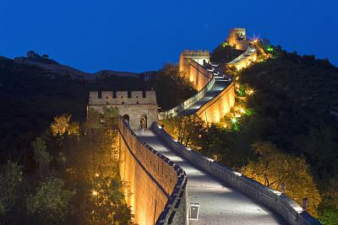

In December 1987, the Great Wall was placed on the World Heritage List by UNESCO.It has drawn tens of

millions of tourists both from home and abroad. More than 370 foreign leaders and celebrities have visited it, including former US presidents Nixon, Reagan, Carter, and Gorge W Bush, Queen Elizabeth II of UK, and former South Africa president Mandela.

四川 SICHUAN

Sichuan Cuisine：Red and Hot

Sichuan Province is a large basin with an excellent geographical location, called Bashu in ancient times. A beautiful place with rich outputs, Sichuan has always enjoyed its praising reputation as a ‘nature's storehouse’. Sichuan cuisine has already been famous in the Han and Tang Dynasties. The poet Du Fu in Tang Dynasty once wrote in his poem: “With green bamboo greeting the boat, the river fish becomes the daily cuisine ” , representing the diverse Sichuan cuisine.

四川古称巴蜀，巴山蜀水，美不胜收，物产充裕，素有“天府之国”之美称。“川味”在汉唐时期就已名扬天下，唐代诗人杜甫有“青青竹笋迎船入，日日江鱼入馔来”的诗句，生动形象地描绘了川菜的丰富多样。

China is renowned for great dishes, while Sichuan is renowned for great flavor. The

feature of Sichuan cuisine lies in its special flavor. The number of its complex flavors is quite a lot. The commonly used types are salty fresh, sweet and salty, fish-flavored, bean paste, homemade, hot pepper oil, tongue-numbing spicy, special spicy, garlic spread, hot and sour, etc. Among them, fish-flavored, homemade and special spicy flavors are very unique here. Local seasonings are very distinctive, including Sichuan salt, Sichuan pepper, Pixian county bean paste, Kuan-chung Baoning vinegar, Xinfan pickles. Third, the Sichuan cuisine is unique for its various cooking methods. There are over 30 commonly used cooking methods. These dishes have their distinctive features and been very popular both home and abroad.

食在中国，味在四川。川菜之美在于味。川菜地复合味型颇多，常用的味型有咸鲜、咸甜、鱼香、豆瓣、家常、红油、椒麻、怪味、蒜泥、酸辣等二十多种，其中，鱼香、家常、怪味为川菜独有。川菜的地方调味料也极具特色，川盐、川椒、郫县豆瓣、关中保宁醋、新繁泡菜等独具特色。川菜之所以如此美味是因为其独特的烹调方法，川菜常用的烹调方法有三十多种，特色鲜明，菜式大众化，遍及海内外，广受欢迎。

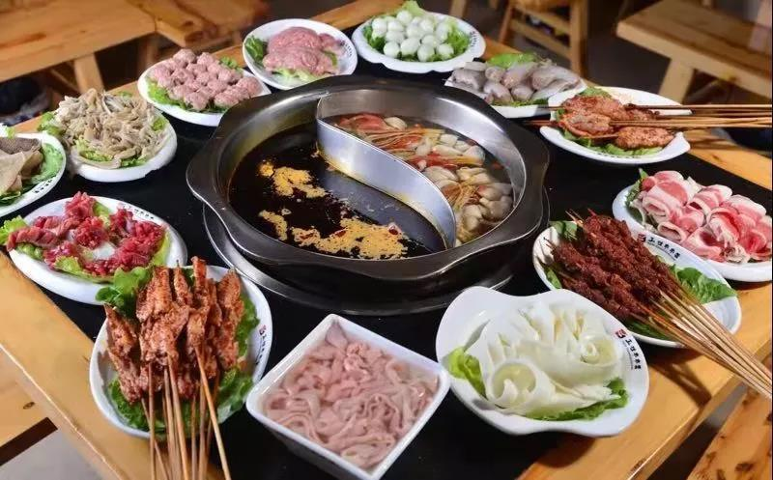

Sichuan-style hot pot and Sichuan-style spicy dishes are the most representative among Sichuan cuisines. They can be found in restaurants around the city, attracting people with their unique charm. Sichuan-style hot pot is very popular because of the hot soup base with unique recipe. There are over 10 kinds of seasonings, including butter, Pixian bean paste, white wine, fermented glutinous rice, hot pepper, ginger, garlic, prickly ash, lobster sauce, rock sugar, chili powder, green onion, etc. and over a dozen aromatic ingredients like ginkgo, Caoguo, clove, vanilla, etc. Raw materials for the hot pot include both meat and vegetables and are made by strict processing rules. There are red broth (spicy), white broth (not spicy), and half red and half white broth. Diners can choose whatever they like. Hot pot has become a cultural symbol of Sichuan. The beautifully decorated hot pot restaurants in the street, the small hot pot restaurants alongside the alley, the red desks and red chairs together with the hot pot flavor have become an attractive scenery in Sichuan.

在川菜中，川式火锅、川式辣味最富有代表性，川锅遍布于各地市肆酒家中，以其独特的魅力吸引食客，

人们为之“乐吃不疲”，陶醉其中。川式火锅之所以广受欢迎，是因为其独特的底汤，这种底汤由牛油、郫县

豆瓣、白酒、醪糟、糍粑辣椒、生姜、大蒜、花椒、豆豉、冰糖、辣椒面、大葱等十几种食材构成，调香料有

白果、草果、丁香、香草等十几味，制汤原料荤素兼备，经严格的加工工艺制成，有红汤（毛肚火锅）、白汤

（清汤火锅）之分，还有合而一锅的“鸳鸯火锅”，任客自便。而今火锅已经成为四川食文化的一个鲜明代表。

从大街上精心装修的火锅店，到小巷里一家挨一家的“麻辣烫”小火锅店，红桌红凳，火锅飘香，宛如一道亮

丽的风景。

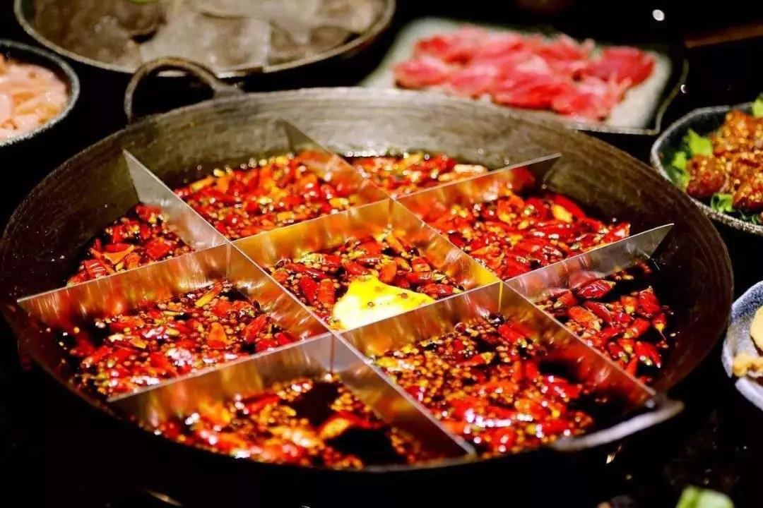

武侯祠 Wuhou Temple

武侯祠,位于成都南郊,是中国纪念诸葛亮最著名和最具影响力的寺庙。诸葛亮是中国著名的历史人物之一，

三国时期他是蜀国皇帝刘备（161-223）的名臣和军事战略家，因此这座寺庙纪念诸葛亮的同时也纪念着皇帝

刘备。武侯祠始建于清朝 1672 年，由于诸葛亮被封“武乡侯”的称号，这座寺庙才因此得名武侯祠。武侯祠

是成都著名景点之一，祠内陈列有许多雕像如刘备、诸葛亮以及蜀国当时多位著名官员，除此之外祠内还有中

国诸多著名的古代铭文和碑刻。

The Wuhou Temple (The Temple of Marquis Wu) in Chengdu's south suburb is the most famous and influential of the temples dedicated to Zhuge Liang who lived from 181 until 234 AD. He is one of China's famous historic figures, and he was a renowned minister and military strategist for Emperor Liu Bei (161-223) of the Shu Kingdom during the Three Kingdoms period in China. The temple is also dedicated to Emperor Liu Bei. It was built during the Qing dynasty in 1672. Because Zhuge Liang was granted the title of "Wuxiang Hou" (Marquis Wuxiang) in his lifetime, this temple is

known as the Wuhou Memorial Temple. The temple is one of Chengdu's major attractions and contains numerous statues to Emperor Liu Bei, Zhuge Liang and other officials of the Shu Kingdom, and there are ancient inscriptions and tablets that are famous in China.
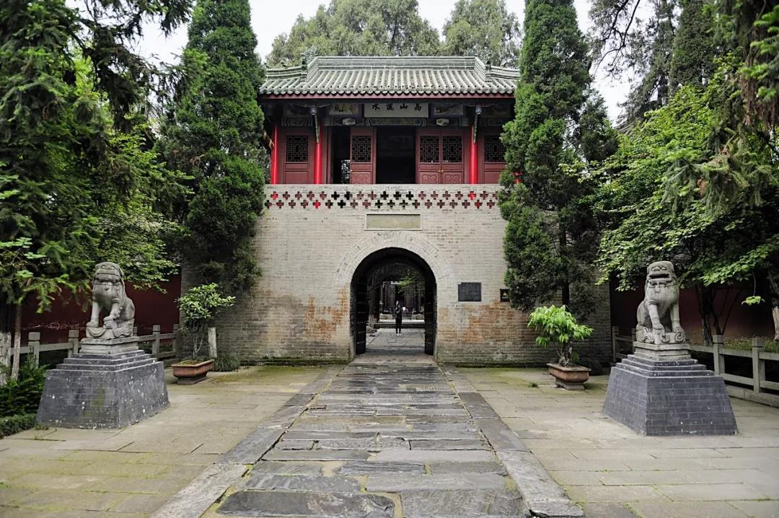

武侯祠占地面积 37,000 平方米（398,277 平方英尺），它准确的初建时期史书尚无记载时至今日已经无

从考证。但可以确定的是，武侯祠毗邻明朝修建的刘备墓。现在的武侯祠是于 1672 年重新修建的，其周围环

绕着古老的柏树和古雅的红墙，凸显了怀旧的韵味。

Wuhou Temple covers 37,000 square meters (398,277 square feet). The date ofits establishment is unclear, only that it was built next to the temple of Liu Bei, the emperor of Shu. It was combined with the Temple of Liu Bei at the beginning of the Ming Dynasty. The current Wuhou Temple was

rebuilt in 1672.Surrounded by old cypresses and classical red walls, it evokes nostalgia.

主体建筑大门，二门，汉昭烈庙，过厅，武侯祠五重建筑，严格排列在从南到北的一条中轴线上。武侯祠内，蜀国皇帝和部长们的粘土雕塑并列陈放是祠内的主要特色之一。

The main body of Wuhou Temple is divided into five sections, the Gate, the second Gate, the Hall of Liu Bei, the corridor, and the Hall of Zhuge Liang, all of which run south to north. Inside, clay sculptures of Shu Emperor and ministers stand together, making them a special feature.

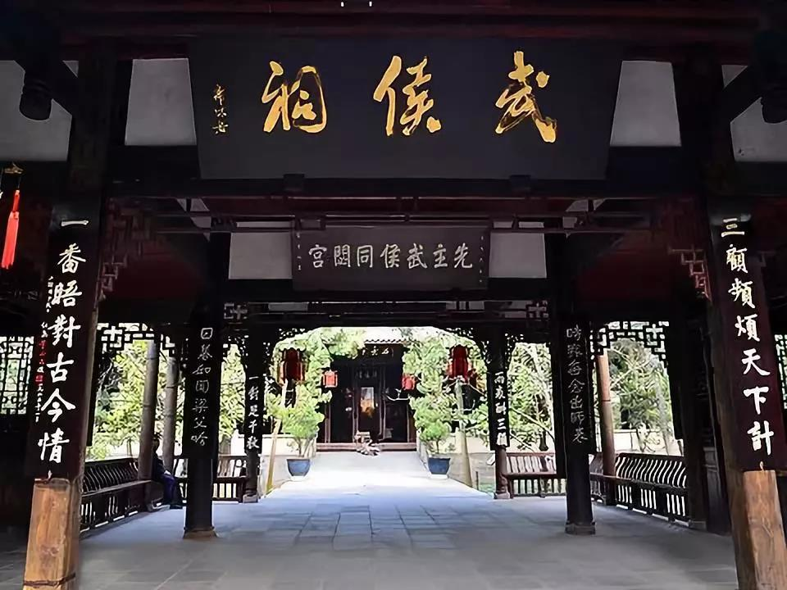

武侯祠最珍贵的文物是 809 年建造的石碑，这块巨大的石碑高 367 厘米（144 英寸），宽 95 厘米（37

英寸），被称为三绝碑。由唐代宰相裴度撰文，书法家柳公绰（柳公权之兄）书写，石工鲁建镌刻。裴文、柳

书、鲁刻，三者俱佳，所以后世誉为三绝碑。一说三绝指诸葛亮的功绩、裴度的文章、柳公绰的书法。 碑阳、

碑阴、碑侧遍刻唐、宋、明、清时代的题诗、题名、跋语。

The most valuable cultural relic in Wuhou Temple is the stele set up in 809. This huge stele 367-centimeter (144-inch) high and 95-centimeter (37-inch) wide is called the Triple-Success Stele. The three successes are: an article written by Pei Du, a famous minister of the Tang Dynasty who served four emperors in succession, calligraphy by Liu Gongquan, one of the most brilliant calligraphers in Chinese history, and a statement about the morality and achievements of Zhuge Liang.

成都大熊猫繁育研究基地 Chengdu Research Base of Giant panda breeding
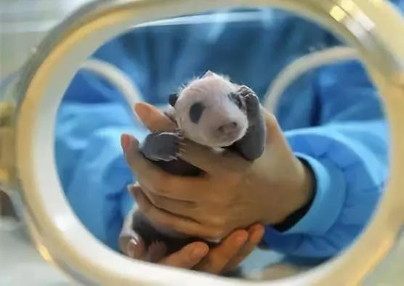

成都大熊猫繁育研究基地地处成都市北郊斧头山，距市区 10 余公里，交通便利，具有开展大熊猫特色旅

游的独特地理优势。自建立以来，完全模拟大熊猫野外自然生态环境的造园手法，建有湖池、溪流，观赏植物

林带、草坪等，栽种竹林和植物林，建有多处模拟自然兽穴，配合山石、洞穴、树穴等，将自然的山野风光与

优美的人工景观巧妙地融为一体，使环境更接近自然，营造了动物生存繁衍的良好环境。

The Panda Base is easily accessible, as it is located no more than 10 kilometers north of Chengdu on the Futou Mountain, which is a unique geographical advantage for tourism development featuring giant panda. Rivers, lakes, brooks, ornamental forest belts and lawns, wild bamboo forests and, woods, man-made dens, rocks, caves and plant pits, simulates the panda’s natural ecological environment since its establishment. The natural scenery blended with artificial landscape ingeniously, creating a natural and favorable environment for animals to survive and prosper.

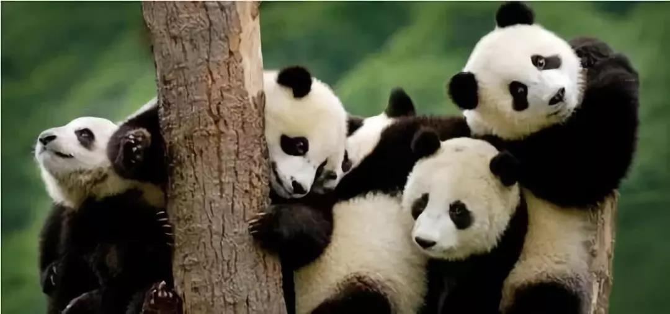

基地现种植有观音竹、琴丝竹等景观竹，经过多年的栽培，在园区内已形成了与大熊猫特色旅游景区自然环境和谐交融的竹林参观道。同时，植被丰富，种有樱花、大叶樟等多种具有观赏价值的特色植物。园区内还饲养了小熊猫、白天鹅及孔雀等多种珍稀濒危野生动物，多种野生鸟类、蝴蝶和数百种昆虫也在此生息繁衍。此外，在仿生运动场，游客可近距离观看不同年龄段的大熊猫的生活状态，看大熊猫或卧或坐，或饮或嬉，或进或出的嬉戏画面。在大熊猫产房，可零距离欣赏大熊猫母亲哺育幼仔的生动场景。

The base is now planted with Fernleaf hedge bamboo, Qinsi bamboo and other ornamental bamboos. After years of cultivation, a bamboo forest visiting road has been formed in the park that is harmonious with the natural environment of the giant panda scenic spots. At the same time, the Panda Base is rich with vegetation, and there are many kinds of characteristic plants with ornamental value such as cherry blossoms and big leafhoppers. It is also inhabited by other endangered wildlife, including pandas, swans, peacocks, birds, butterflies and hundreds of insects. The Panda base is known as the best tourist destination to get closer to the rare giant pandas. Visitors can closely observe the giant pandas of different ages resting, eating and drinking, playing with each other, coming in and out, or watch female pandas nursing their cubs in the nursery rooms.

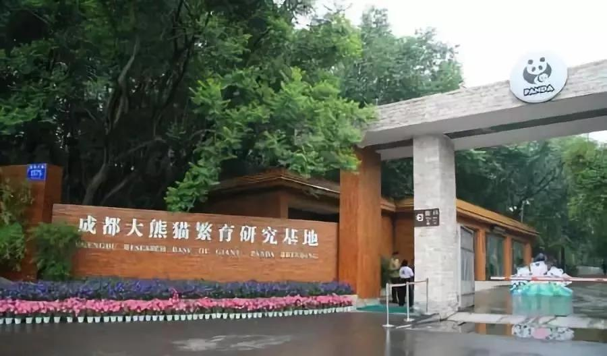

成都大熊猫繁育研究基地作为国家、省、市窗口单位，自成立以来先后接待了数十个国家的领导人和嘉宾，并于 2006 年被国家旅游局正式授予“国家 AAAA 级旅游景区”。

The Panda Base has served as a national, provincial and municipal demonstrative model to the world, welcoming state leaders and distinguished guests from dozens of countries since its establishment. In 2006, it was officially awarded the "National AAAA Level Scenic Spot" by the National Tourism Administration.

青城山 Qingcheng Mountain

青城山位于成都以西 65 公里处的都江堰市，是中国道教发祥地之一。这座山上有许多道教寺庙和曲折迂回的登顶小路。青城山风景区常年郁郁葱葱，以其宁静悠远而闻名。上有“天下第五名山”、“青城第一峰”等摩崖石刻。其年平均温度为 15 摄氏度，属亚热带温湿型气候，素有“洞天福地”之美誉。（意为风景优美、满载幸福之地）。

Qingcheng Mountain is located in Dujiangyan 65 kilometers west of Chengdu. Qingcheng Mountain is one of the ancient cradles of Daoism. The mountain has numerous Daoist temples and sites along the paths to its peak. The area is green all year round and is known for its secluded tranquility. There are stone inscriptions as "the fifth famous mountain under the sun", " the first peak in Mt. Qingcheng" and so on in it. With its annually average temperature of 15 centigrade, Mt. Qingcheng belongs to humid subtropical monsoon climate. It is reputed as "Dong Tian Fu Di" (means wonderful mountain and happy place).

青城山群山环绕，葱茏幽翠，树枝直插云霄。青城山分为青城前山和青城后山两个部分。前山以其众多文

化历史遗迹而闻名；后山则以其天堂般的自然风光而闻名，那原始而辉煌、华丽而神秘的山林美景令游客流连

忘返。

Surrounded by countless peaks and densely covered by ancient trees whose branches reaching the sky, the mountain was named "Mt. Qingcheng". The mountain includes two parts-the anterior Mt. Qingcheng and the posterior Mt. Qingcheng. The anterior mountain is famous for its numerous cultural and historic sites; while the posterior mountain is noted for its paradisiacal scenery, primitive and brilliant, gorgeous and mysterious.
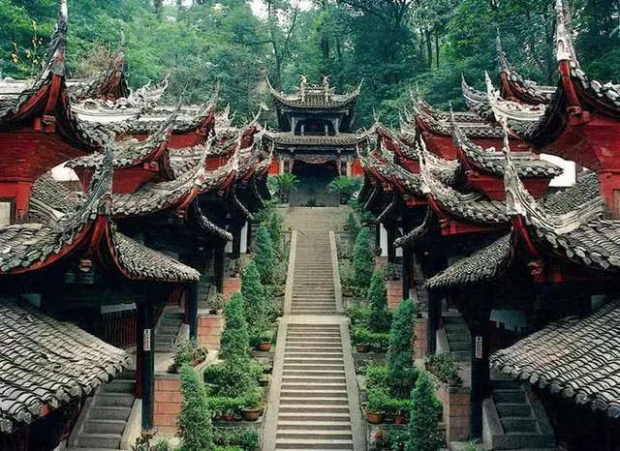

青城山的著名景点主要有：建福宫，天师洞，上清宫等。其中，建福宫与丈人峰下的峭壁遥遥相望，气度非凡。始建于唐开元十八年（公元 730 年），后经历代多次修复，现仅存两殿三院。

The famous scenic sites are: the Shangqing Palace, the Jianfu Palace, and the Tianshi Cave, ect. Among them, the Jianfu Palace, with extraordinary bearing, stands against the barranca under the Zhangren Pea. It was built in Tang dynasty, and repaired for several times in the successive dynasties, now only two halls and three compounds are preserved.

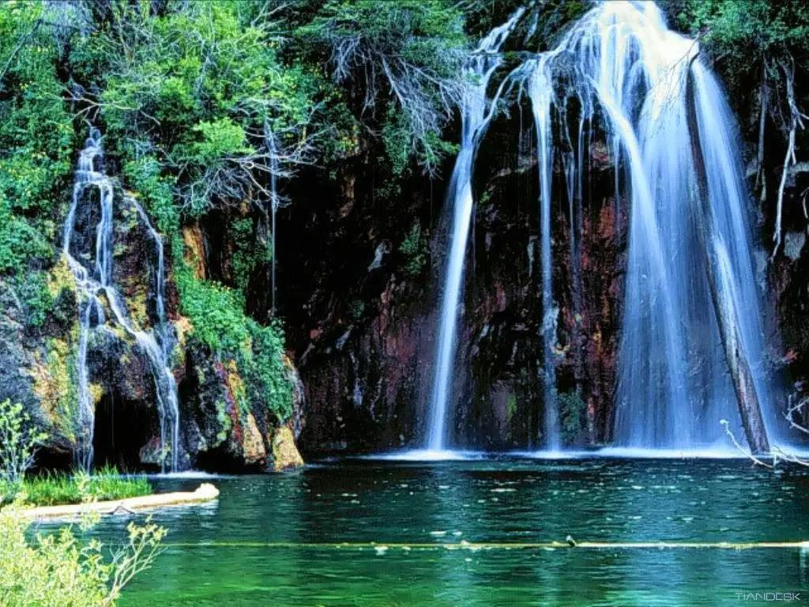

天师洞是青城山最主要的道观。相传东汉末年张道陵曾在此讲经传道。在天师洞的主殿三皇殿，殿内供奉伏羲、神农、黄帝石刻造像，三尊造像均建于唐朝。

Tianshi Cave is the major temple of Mt. Qingcheng. According to legend, in the Eastern Han dynasty, Zhang Daolin had been here for preaching. In the Three Kings Palace, the main hall of the Tianshi Cave, the stone inscriptions of three kings of Tang dynasty were laid.

上清宫始建于晋朝，现存的寺庙始建于清代同治时期。

The Shangqing Palace was first built in the Jin dynasty and the extant temple was built during the reign of Tongzhi in Qing dynasty.
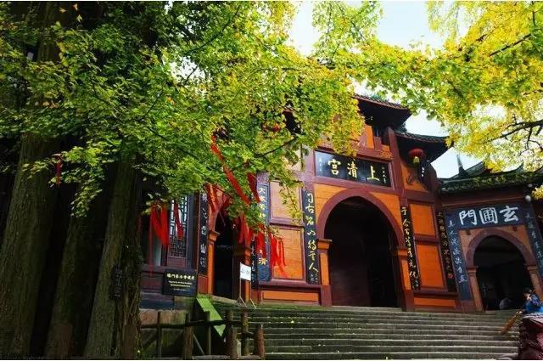

青城派太极宗师-刘绥滨 Taiji Master-Liu Suibin
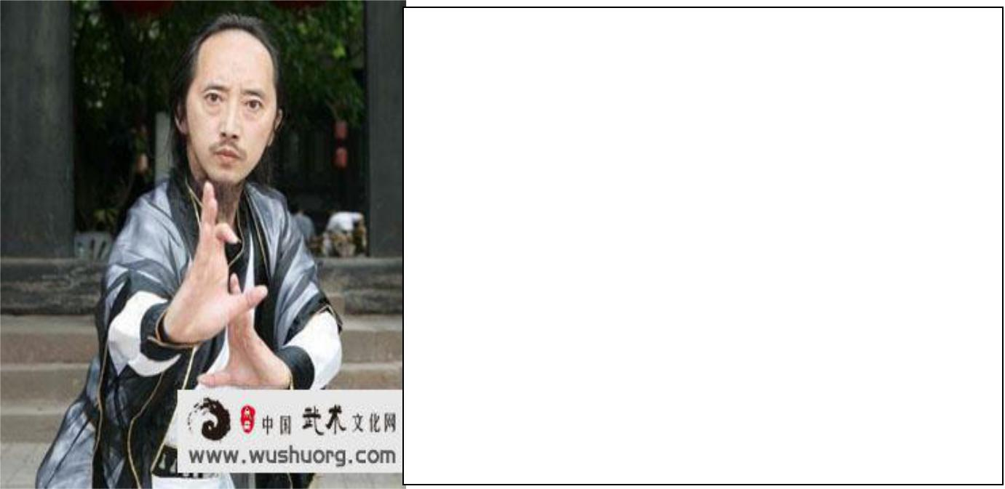

中华太极人物三十人、传统武术十大领军人物、全球中华文化艺术薪传奖，连续六届受聘为中华养生健康国际论坛形象大使。

He is regarded as one of the best Taiji martial arts among 30 Taiji masters. He is also the top ten traditional martial arts figures and has been employed as the ambassadors of the China Health and Wellness International Forum for six consecutive years.

道名信玄，自幼师从蒋信平道长等十余高道大德、名家隐士习武修道统，曾获四川省非物质文化

遗产代表性传承人、中国电视吉尼斯擂主、国际及世界武术比赛冠亚军。

Xinxuan is his Taoist name. Since the early childhood, he has been taught by martial arts Master Jiang Xinping, and more than other ten high morals. He has been the representative inheritor of the intangible cultural heritage of Sichuan Province, the Chinese TV Guinness lord, international and world martial arts competition champion and runner-up.
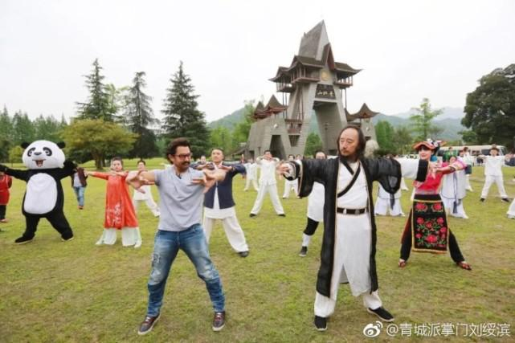

2001 年,他被余国雄宗师授权成为青城派武术第 36 代掌门人， 曾执教全球多家高校及高端培

训机构，弟子、学生遍及全球 80 余个国家，目前在新浪微博粉丝超过 48 万，多次应邀率弟子参加

国内外大型活动，为各国政要、影视歌星、文化名人、企业家作武术、太极展示及养生教学。他曾入

选中国《少林与太极》杂志、《武当》杂志、美国《功夫与太极》杂志、法国《太极》杂志封面人物；

继国际巨星成龙之后，2009 年第十五届全球中华文化艺术薪传奖评选中（全球 122 个国家人士参选），

刘绥滨荣获“中华武艺奖”，成为亚洲和中国大陆唯一的获奖代表。

In 2001, he was authorized by Yu Guoxiong to become the 36th generation of Qingcheng School martial arts. He has taught many universities and high-end training institutions around the world. His disciples and students are in more than 80 countries around the world. Currently, he has more than 480,000 fans on Sina Weibo. He was also frequently invited together with his disciples to participate in large-scale activities at home and abroad, and to do martial arts, Tai Chi show and health teaching for politicians, film and television stars, cultural celebrities, entrepreneurs. He was selected as the cover of China's "Shaolin and Taiji" magazine, "Wudang" magazine, American "Kung Fu and Taiji" magazine, and French "Tai Chi" magazine. After the international superstar Jackie Chan, In the selection of the 15th Global Chinese Culture and Art Salary Award in 2009 (persons from 122 countries around the world), Liu Yubin won the "Chinese Warrior Award" and became the only award-winning representative in Asia and China.

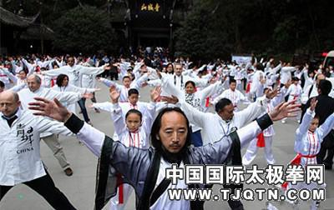

现为都江堰市政协常委、四川省道教协会常务理事、四川省旅游学校巴蜀武术养生学院院长、四

川省武术文化研究会会长等等。他被全球 600 余家媒体报道过，并超过 30 万次及转载。

He is currently a member of the Standing Committee of the Dujiangyan CPPCC, the executive director of the Sichuan Provincial Taoist Association, the president of the Sichuan Provincial Tourism School Bayu Martial Arts Health Institute, and the president of the Sichuan Wushu Culture Research Association. He has been reported by more than 600 media outlets worldwide and has been shared more than 300,000 times.

都江堰 Dujiangyan

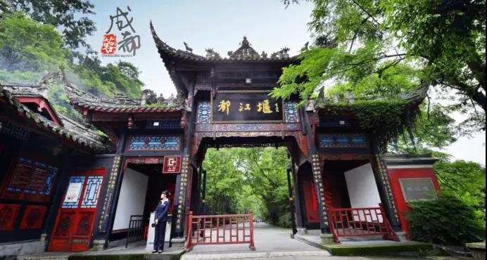

Dujiang Weir, or Dujiangyan Irrigation System, is located west of Dujiangyan City, Sichuan Province. The system is a large hydraulic water project which consists of three main parts: the Fish Mouth Water-Dividing Dam, the Flying Sand Fence, and the Bottle-Neck Channel. Since Song and Yuan Dynasties it was given the present name Dujiang Weir，honored as the"Guarding Treasure of Sichuan Province" that is"ingenious of all times". Originally constructed around 256 BC by the State of Qin as an irrigation and flood control project, it is still in use today.

都江堰，位于四川省都江堰市西部。该系统是一个大型的水利工程，主要由三部分组成：鱼嘴分水大坝、飞砂栅和瓶颈通道。宋元后称都江堰，被誉为独奇千古的“镇川之宝”。最初由秦国建成于公元前 256 年，都江堰作为灌溉和防洪工程至今仍在使用。
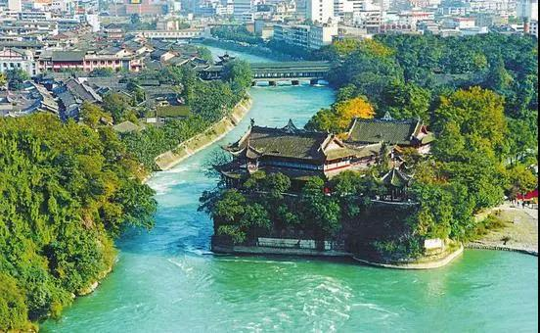

The irrigation system was constructed by Li Bing, governor of Shu Prefecture over 2 200 years ago. It is not only the earliest water control project in China，but also the only and the oldest remain of such in the whole world. Characterized in its successful control of water without any blocking dam，Dujiang Weir is a milestone in the history of technology in China.

都江堰是由蜀郡守李冰主持兴建的，至今已有 2 200 多年的历史，是中国最古老的水利工程，也是全世

界迄今为止年代最久、唯一留存、以无坝引水为特征的宏大水利工程。同时，都江堰也是我国科技史土的一座

丰碑。
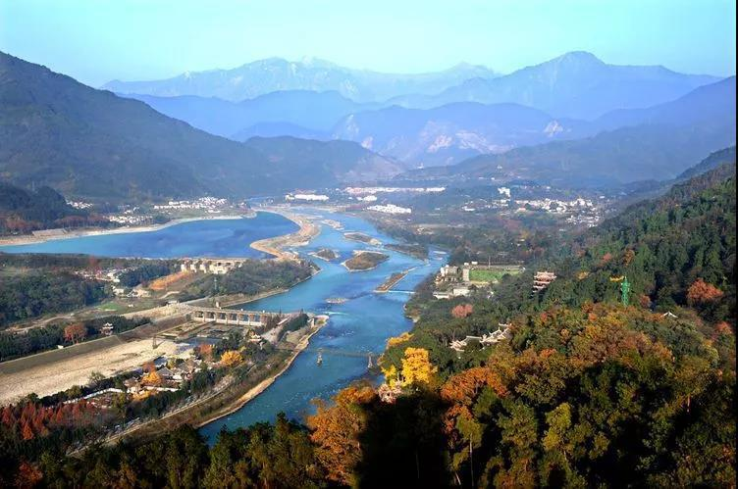

乐 山 大 佛 Leshan Giant Buddha
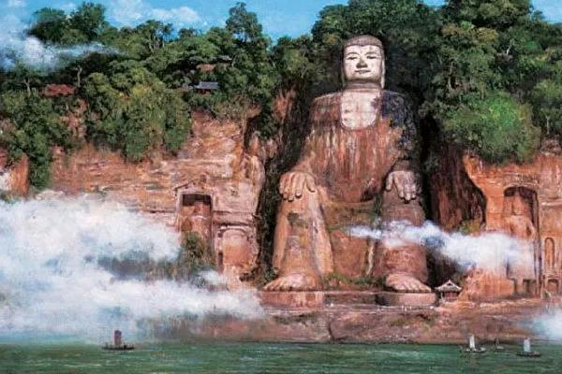

乐山大佛景区位于岷江、青衣江、大渡河三江汇流处，是世界文化与自然遗产。景区面积 17.88 平方公里，人文景观和自然景观独具特色。这里有世界最大摩崖石刻弥勒坐像——乐山大佛、自然和人文奇观——“巨型睡佛”、青衣别岛——乌尤寺、东汉麻浩崖墓、佛教艺术荟萃——东方佛都、宋元古战场遗址——三龟九顶城。

景区依山傍水，风光旖旎，名胜古迹星罗棋布，恰似天然画卷，美不胜收。或拾阶登临，或游江观瞻，荡漾于青山绿水间、浸润于诗情画意中，令人心旷神怡，流连忘返。

Located at the junction of the Min River, Qingyi River and Dadu River, Leshan Giant Buddha Scenic Area is a world cultural and natural heritage. The scenic area covers 17.88 square kilometers and has many attractions such as the Giant Buddha of Leshan-the world's biggest stone sitting Buddha statue, the Giant Sleeping Buddha which is a miraculous work by nature and man, the Wuyou Temple on the Isolated Hill, the Mahao Cliff niches dated back to the Eastern Han dynasty, the Oriental Capital of Buddhism with a collection of Buddhist arts and the ruins of ancient battlefield in Yuan and Song Dynasties.

Surrounded by hills and rivers, dotted with historical and cultural relics, this area resembles a natural scroll of landscape paintings. Drifting on the river or climbing up the mountain steps will surely make you feel extremely relaxed and happy.

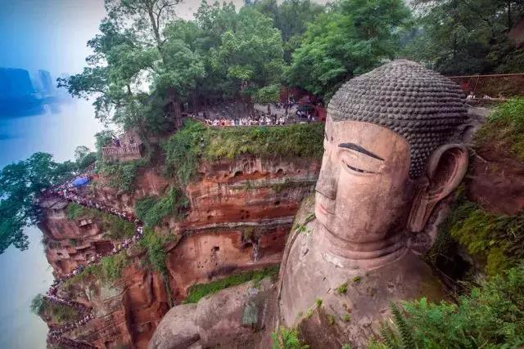

上海 SHANGHAI

上海美食 Native Food

生煎 Sheng jian
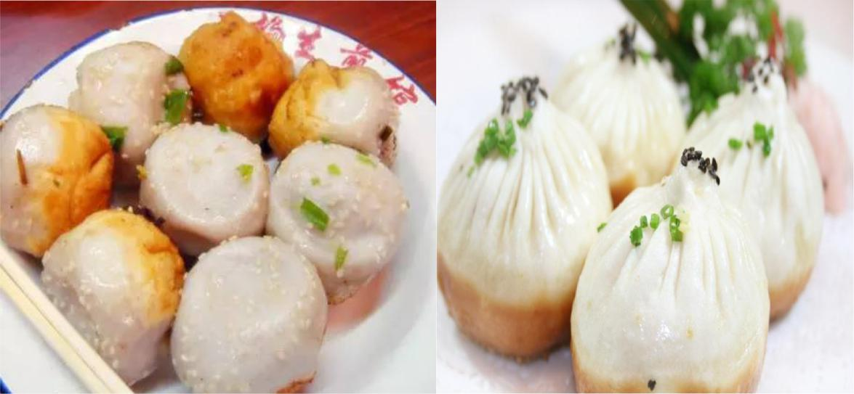

Sheng jian , is a native of Shanghai dim sum, has a history of more than 100 years. The semi fermented flour is covered with fresh meat and frozen skin. It is placed in a pan in rows and Fried in oil. During the frying process, it is drizzled with cold water several times. Fried food is very popular in Shanghai, and it's no wonder that raw and Fried steamed buns are everywhere on the streets. Raw Fried steamed bread with halal beef inside the core, especially delicious juicy.

上海人也叫“生煎馒头”，是土生土长的上海点心，已有上百年的历史。半发酵的面粉包上鲜肉和肉

皮冻，一排排地放在平底锅里油煎，在煎制过程中还要淋几次凉水，最后撒上葱花和芝麻就大功告成

了。

小笼包 Nanxiang small steamed bun (Xiao long bao)
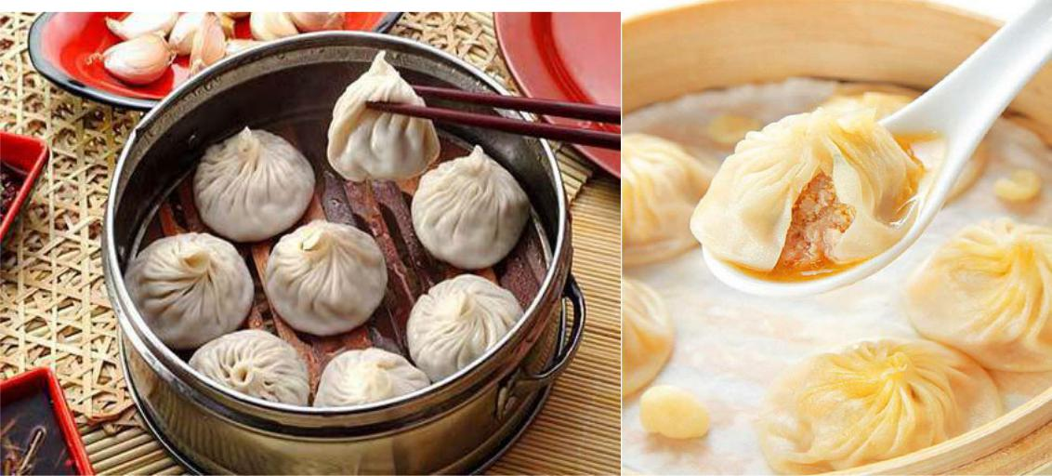

Originally known as Nanxiang meat steamed bread, Nanxiang small steamed bun is famous traditional food in Jiading district, Shanghai Nanxiang town. The wrapping is thin, the fillings are juicy, the meat tender and the taste delicious and not at all greasy. For the bun, natural fresh juice is the essence.

南翔小笼包原名南翔肉馒头，是上海南翔镇嘉定区著名的传统食品。外皮薄，馅料多汁，肉质鲜嫩，

味道鲜美，一点儿也不油腻。对于小圆面包来说，天然新鲜的果汁是最重要的。

三鲜馄饨 three delicacies wonton
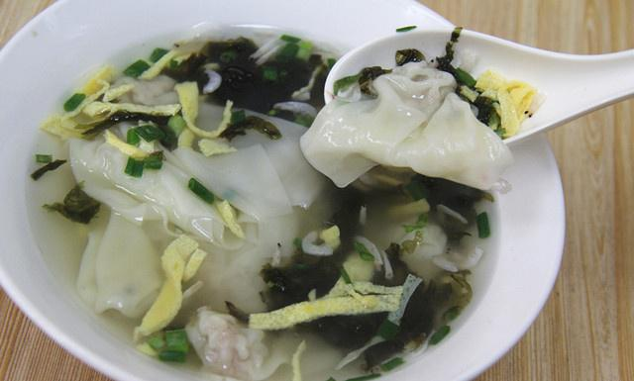

Just as an old saying” Gently, slowly move, first open the window, after sucking soup”.

Shanghai three delicacies wonton is different from Wuxi three delicacies wonton. Wonton filling is not made of fresh meat, dried shrimp meat and pickle, instead of pure meat. The wonton tricks are in the soup. Egg, dried small shrimps and seaweed wrapped in fresh meat makes it taste salty and sweet smooth

就像一句老话“轻轻，慢慢移动，先打开窗户，后吸水”。

上海三珍馄饨不同于无锡三珍馄饨。馄饨馅不是用鲜肉、虾仁和腌菜做的，而是用纯肉做的。馄饨的

花样在汤里。鸡蛋、虾仁和海带包裹在鲜肉里，吃起来咸甜爽滑。

定胜糕 Lucky cake
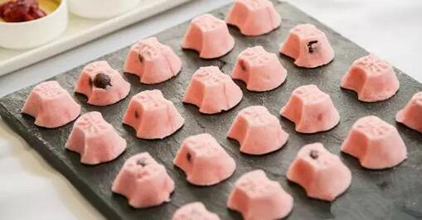

Lucky cake has a sweet taste with soft fragrance and its color is pink. If you want to make it, first you can put rice into a special plate, then put a red bean paste and among steam for a little time.

It is said that the cake is used for cheering YueJiaJun war soldiers in the southern song dynasty. Two words is written on the cake "wins", so the cake is called after the "victory cake".

定胜糕口味香甜，香味柔和，颜色为粉红色。如果你想做它，首先你可以把米饭放进一个特殊的盘子

里，然后把红豆酱和蒸汽蒸一会儿。据说，南宋时期，月饼是用来为岳家军战士助威的。蛋糕上写着

“胜利”两个字，所以蛋糕就叫做“定胜糕”。

红烧肉 Hongshaorou (red braised pork belly)
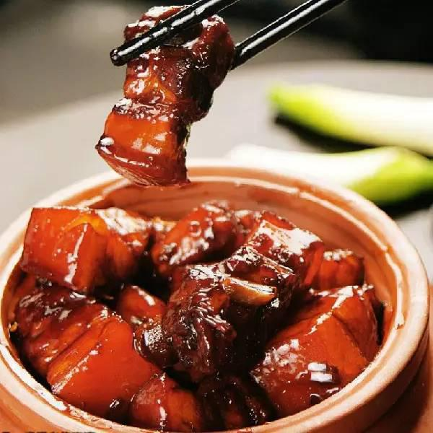

Undeniably the symbol of Shanghainese cuisine, hongshaorou is rich in flavor and heavy in sauce. It's a dream for pork lovers.

After hours of braising, the lean meat of the pork belly becomes extremely juicy, thanks to layers of fat.

毋庸置疑，红烧肉乃是上海菜肴的标志。味全汁多的猪肉，乃是食肉一族的大爱呀。用文火炖煮几小

时后，五花肉的精肉部分再淋上鲜美浓香的肉汁（肥肉炖煮之后形成）。

排骨年糕 Ribs rice cakes
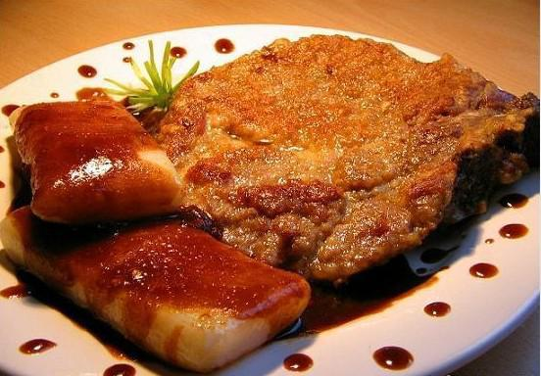

It is another affordable and unique local snack in Shanghai. Pork spine meat, marinade with soy sauce, and then put oil, sugar, ginger, wine and other mixed oil pot, taste fragrant when taken out. Plus a piece of New Year cake, is the Shanghai spareribs cake. Special hint: eat spareribs New Year cake, must be dipped in "chili sauce", this is a Shanghai specialty, almost no other place.

它是上海另一种经济实惠、独具风味的本地小吃。将猪脊骨肉，用酱油腌渍后，再放入油、糖、葱姜

末、酒等混合的油锅中，味道浓香时取出。再加上一块年糕，就是上海的排骨年糕了。特别提示一下：

吃排骨年糕，一定要沾着“辣酱油”，这也是上海特产，其他地方几乎没有。

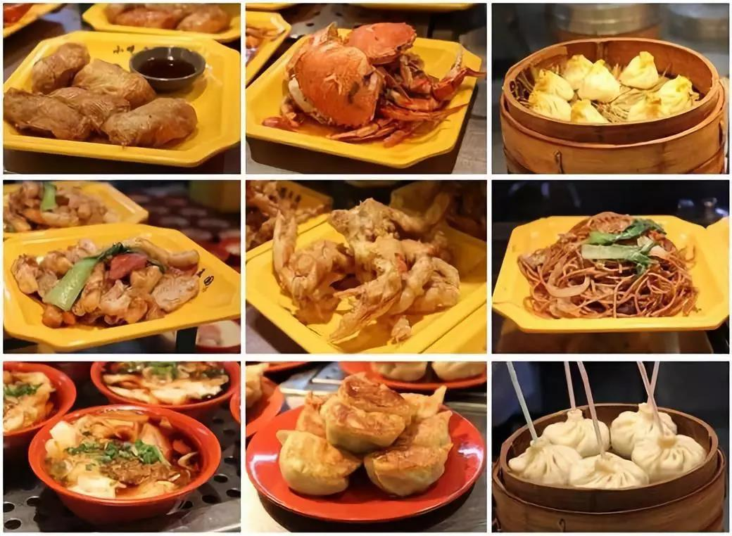

A wide variety of cuisines can be found in the City and today Shanghai offers a plethora of culinary delights focusing on the traditions of Beijing, Yangzhou, Sichuan, Guangzhou as well as its own local dishes. Shanghai's restaurants are among the finest to be found in China and they welcome diners from anywhere at any time.

上海城里的名吃佳肴也是名目繁多，数不胜数。如今，上海为游客们提供了一套丰富多彩且美

味可口的菜单，其中包括北京风味，四川风味，广州风味以及上海地方特色的菜肴。上海的餐

馆都是在中国一流餐馆之列，它们随时都在恭候着各地游客们的光顾。

浦东陆家嘴和东方明珠 Lujiazui and the Oriental Pearl TV Tower

The Oriental Pearl TV Tower is located in Pudong Park in Lujiazui, Shanghai. Stands a staggering 468 meters making it one of the tallest towers in Asia. The tower, surrounded by the Yangpu Bridge in the northeast and the Nanpu Bridge in the southwest, creates a

picture of "twin dragons playing with pearls".

It is amazing that this ultra-modern tower combines ancient concepts such as the spherical pearls, with 21st Century technology, commerce, recreation, educational and conference facilities. All of this and it really is a TV and radio tower that services the Shanghai area with more than nine television channels and upwards of ten FM radio channels. Truly, "oriental

pearl" is the most suitable name for this tower.
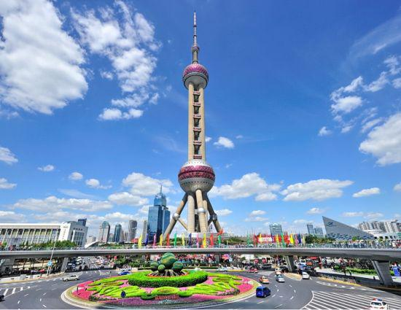

东方明珠电视塔位于上海陆家嘴浦东公园。 它高达 468 米，是亚洲最高塔楼之一。 该塔由东北的

杨浦大桥和西南的南浦大桥环绕，形成了“双龙戏珠”的画面。

令人惊奇的是，这座超现代的塔楼结合了古老的概念——球形珍珠，和 21 世纪的现代技术，集商业，

娱乐，教育和会议一体设施。除去这一切，它也是一个电视和无线电塔，为上海地区提供超过 9 个

电视频道和 10 个广播频道。 “东方明珠”实至名归！

The Huangpu River is a tributary of the Yangtze. You'll see the magnificent building skylines on both the historic west side (the Bund), and the modern east side (Pudong). It's fun to see such lively river life as well as Shanghai's amazing skyline. It is a good way to relax a bit and sight-see at the same time.

黄浦江是长江的支流。随着游轮，你可以在在西侧（外滩）看到历史悠久的万国建筑群，在东侧（浦

东）看到宏伟的现代化的摩天大楼和上海令人惊叹的天际线 。

The Bund along the river faces the modern skyscrapers of Lujiazui in the Pudong District. The Bund houses 52 buildings of various architectural styles, generally Eclecticist, but with some buildings displaying predominantly Romanesque Revival, Gothic Revival, Renaissance Revival, Baroque Revival, Neo-Classical or Beaux-Arts styles, and a number in Art Deco style.
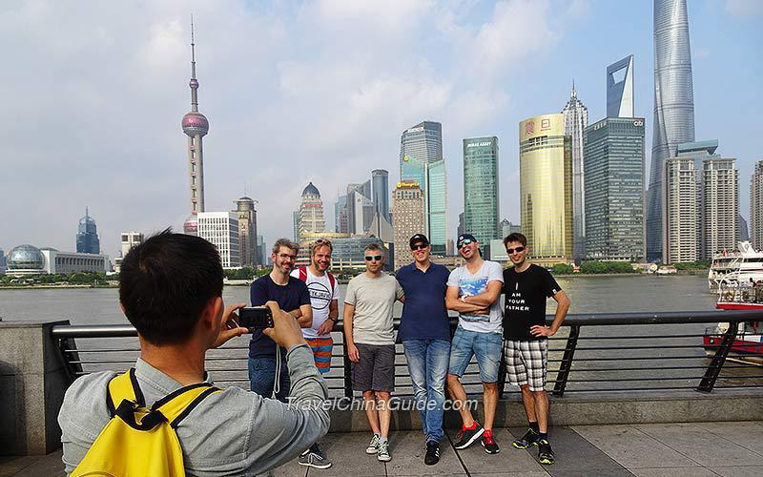

It is one of the most famous tourist destinations in Shanghai.

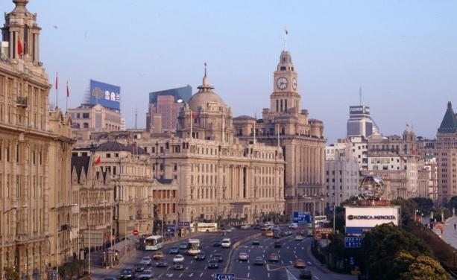

沿着黄浦江，外滩正对着浦东陆家嘴的现代化摩天大楼。它拥有 52 栋各种建筑风格的建筑，有一些

建筑主要展示罗马式复兴，哥特式复兴，文艺复兴时期复兴，巴洛克复兴，新古典或艺术风格，还有

一些装饰艺术风格。它是上海最着名的旅游目的地之一。

视频连接：东方明珠和黄浦江两岸夜景 https://www.youtube.com/watch?v=AoigEqTXRMI

田子坊 Tianzifang
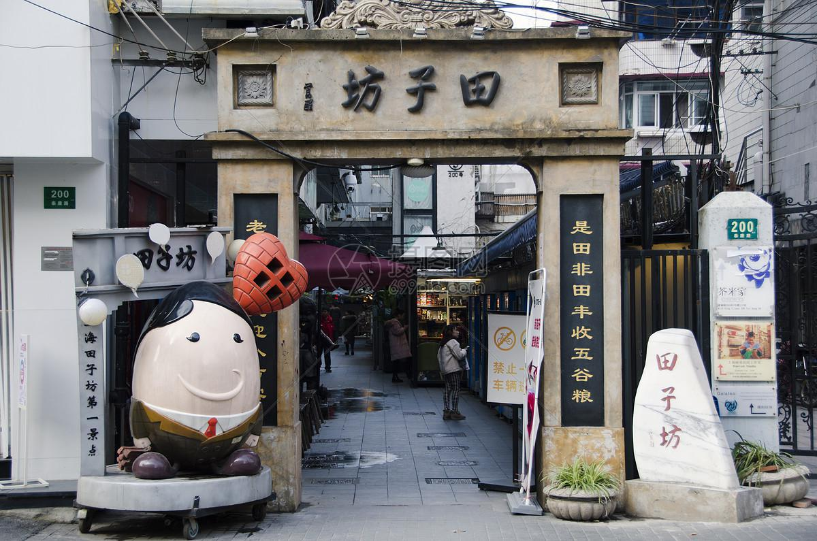

Located in Taikang road,Shanghai,Tianzifang is a nest for many art and design studios, crafts shops and galleries, antique shops and some boutiques, etc. Many coffee shops, bars, tea houses, restaurants, and silk shops here are operated by an international mix of owners.

田子坊位于上海泰康路上，它是汇集大量琳琅满目的艺术设计工作室、工艺品商店、画廊、古董店和精品店的集聚区。来自世界各地的商家在此开设了各色咖啡店、酒吧、茶馆、餐厅和丝绸店铺。
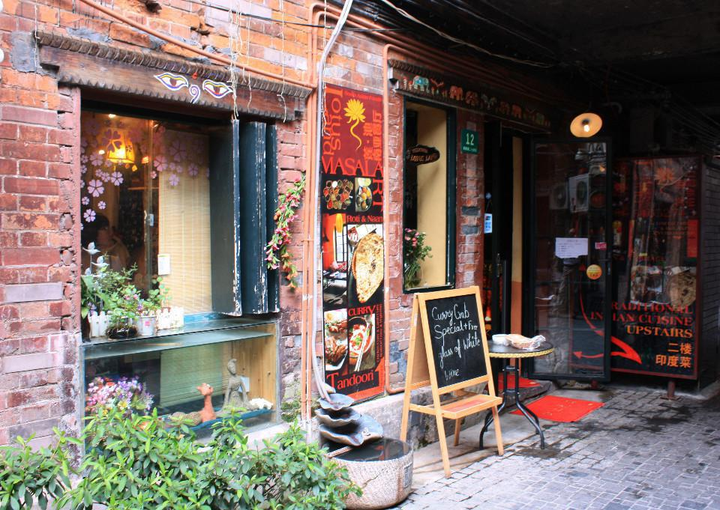

The name of Tianzifang is coined by Huang Yongyu, the vice chairman of the China Artists Association.Tian Zifang is the earliest recorded painter in China. Mr. Huang reworded the last word ‘fang 方' into ‘fang 坊' meaning mill, lane or workshop.

“ 田子坊”其名是由中国美协副主席黄永玉起的雅号。据史载，“田子方”是中国最早的画家。黄永玉先生将“方”改为“坊”，为磨坊、弄堂以及作坊之意。

The development of Tianzifang is fairly recent. Before 1998,this area could only be described as a bazaar that was dusty and messy. Not until some artists moved their workshops to this area when the big change was triggered. Famous artists like Chen Yifei began to work here, which brought an atmosphere of art to this place as well as raised its fame. Nowadays, Tianzifang is called the SOHO in Shanghai.

田子坊是近年才发展起来的。1998 年以前，这里只是脏乱的集市。直到一些艺术家们将他们的工作室入驻于此，这里才真正发生改变。比如著名艺术家陈逸飞先生曾在此工作，为田子坊带来了艺术气息，也提升了它的名气。如今，田子坊被称为上海的“苏荷”。

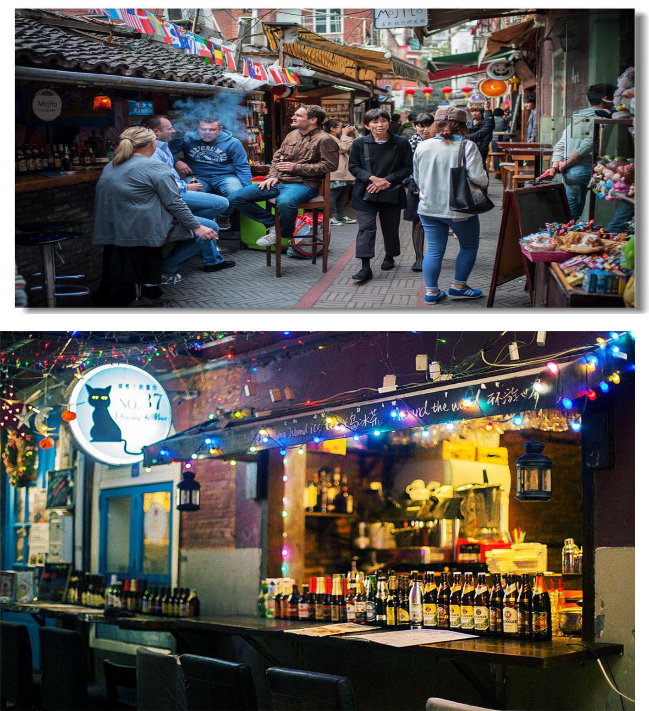

One of the Shanghai highlights is the old residential buildings called ‘shikumen’, literally ‘stone doors’. There are over 20 varieties of well-preserved shikumen buildings in Tianzifang, whose types and completeness rank with the best in the city. The main feature of Tianzifang is that many original residents still live in the narrow lanes. Tianzifang survives the surrounding city demolition by working in art. Its preservation is significant for the city’s cultural heritage.

上海的亮点之一就是古旧的住宅建筑，名为“石库门”，字面意思是“石门”。田子坊有 20 多

个保存完好的石库门建筑，其类型和完整性在这座城市是名列前茅的。田子坊的最大特色就是有许多原住民仍然生活在这里。田子坊通过致力于艺术创作而在周边的城市拆迁中幸存下来，它的保护对于城市的文化遗产具有重要意义。
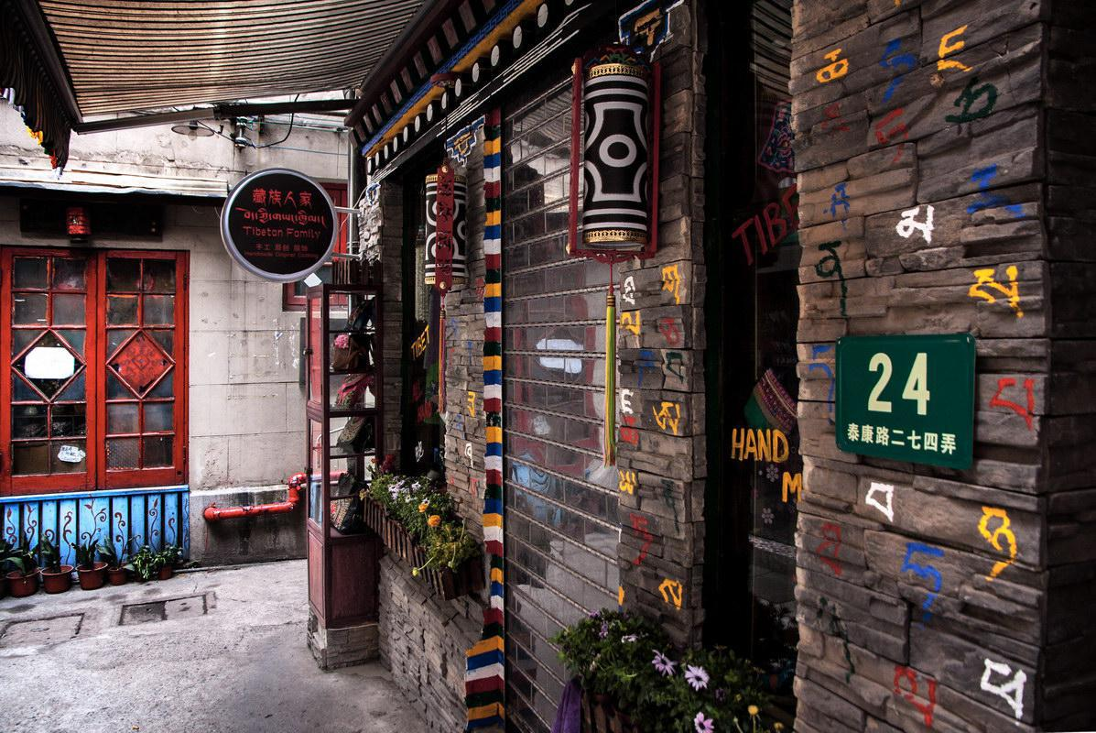

水乡周庄 Zhouzhuang Water Town

Zhouzhuang, a typical water town, is located in the southwestern part of Kunshan, at the junction of Shanghai and Kunshan. It is about 45 kilometres away from Suzhou. Built in the year of 1086, it was named after the local - Mr. Zhou Digong （周迪功）who donated his land to repair the Quanfu Temple.

水乡周庄，位于昆山市西南部，地处上海和昆山的交界处，距苏州约 45 公里。公元 1086 年，因周

迪功先生捐赠土地修缮全福寺而得此名。
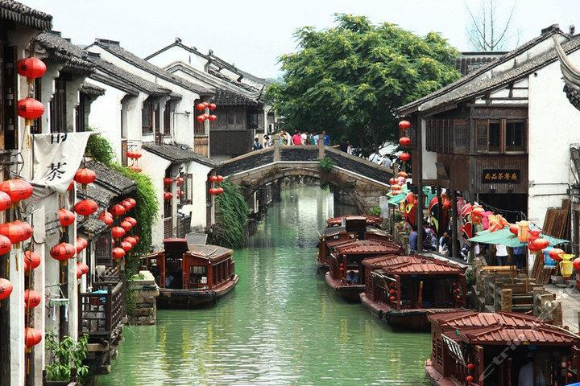

As one of the six great ancient towns in the south of the lower reaches of the Yangtze River, Zhouzhuang enjoys its good reputation as "the first water town in China". To some extent, it is on par with Venice in Italy, recounting its thousand-year history, displaying its gentle spirits, unique human landscapes and unsophisticated folk customs. Nowadays, it has become the gem of the orient and one of the most popular scenic spots for travelers to vacation and take their leisure.

作为长江下游六大古镇之一，周庄素有“中国第一水乡”的美誉。其悠久的历史、独特的人文景观和

简朴的民俗风情，无不向人们展示着周庄丰富的内涵和底蕴，堪比意大利的威尼斯。如今，它已成为

东方的水上明珠，是最受游客欢迎的度假休闲的景点之一。
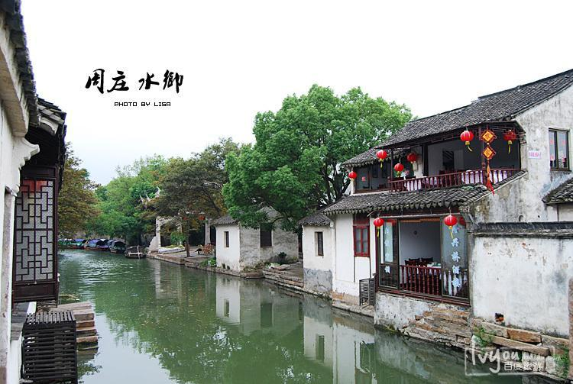

The most famous figure in Zhouzhuang is the richest man Shen Wansan. It says, once Zhu Yuanzhang（ one of emperors of Ming Dynasty ）has visited Shen’s family and praised the pig trotters he cooked. Since then, “Wansan Trotters” has become a famous local cuisine. In the evening, Zhouzhuang also provided visitors with a large-scale water folklore cultural performance called “Four Seasons of Zhouzhuang”. It’s about the story of Shen Wansan and shows the simple hard-working life of locals throughout the whole year.

周庄最出名的人物当属首富沈万三。传说，朱元璋曾到访沈家，对其烹饪的猪蹄赞不绝口，自此，“万

三蹄”便成为了一道当地有名的美食。水镇周庄在傍晚还为游客提供名为“四季周庄”的大型水上民

俗风情表演，讲述了沈万三发家致富的故事，以及一年四季周庄人民辛苦劳作的朴素生活。

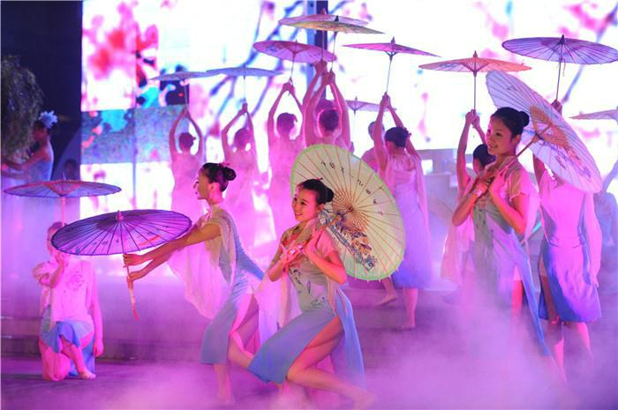

Short video for Zhouzhuang:

https://www.youtube.com/watch?v=mT1tlFZOlds

Shourt video for the performance:

https://www.youtube.com/watch?v=L7bBiNPNmPg

中华门与老门东 Zhonghua Gate and Laomen Dong
中华门是南京明城墙的 | 十三座明代京城城
门之一，原名聚宝门，是 | 中国现存规模最大
的城门，也是世界上保存 | 最完好、结构最复杂
的堡垒瓮城。中华门布局 | 严整、构造独特，是
研究中国古代军事设施 | 的重要实物资料。
Zhonghua Gate (Gate | of China), | is one
of the thirteen capital | gatesof | the
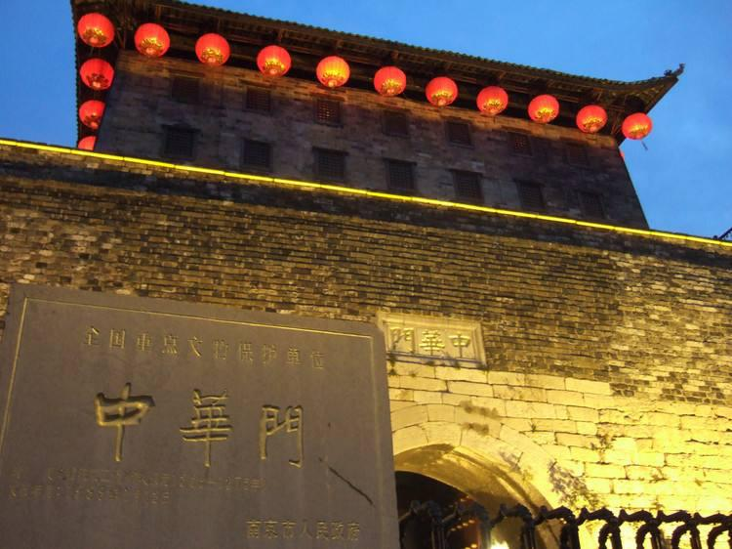

circumvallation built during Ming Dynasty (1368-1644). Zhonghua Gate is known as the

existing gate of largest scale in China, meanwhile, as the city gate with most complex structure in the world. With layout of orderliness and amazing structure, Zhonghua Gate is regarded as precious datum for investigation on Chinese ancient military facilities.
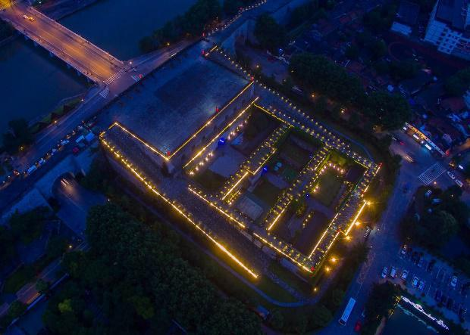

城门设置有三道瓮城、四道券门，呈“目”字形结构，每道

瓮城都有一门一闸，主体建筑内瓮城由中华门主楼城门和二

至四道辅助城门构成，各城门原有双扇包铁门和可上下启动

的千斤闸，内设有栓槽，用来供木栓紧闭大门所用，整个城

共有二十七个藏兵洞，可以藏兵三千余人。

With three barbicans and four sub-gates, Zhonghua Gate formed a structure like the shape of Chinese Character “目” which means eyes. Gates with iron clad and two-way bolts make the gate easy to control while difficult to breach. Twenty-seven soldier caves along the gate and city circumvallation were able to contain more than three thousand of soldiers when necessary.

中华门曾是南唐国都江宁府和南宋陪都建康府城的南门，明朝洪武二至八年（1369 至 1375 年）其
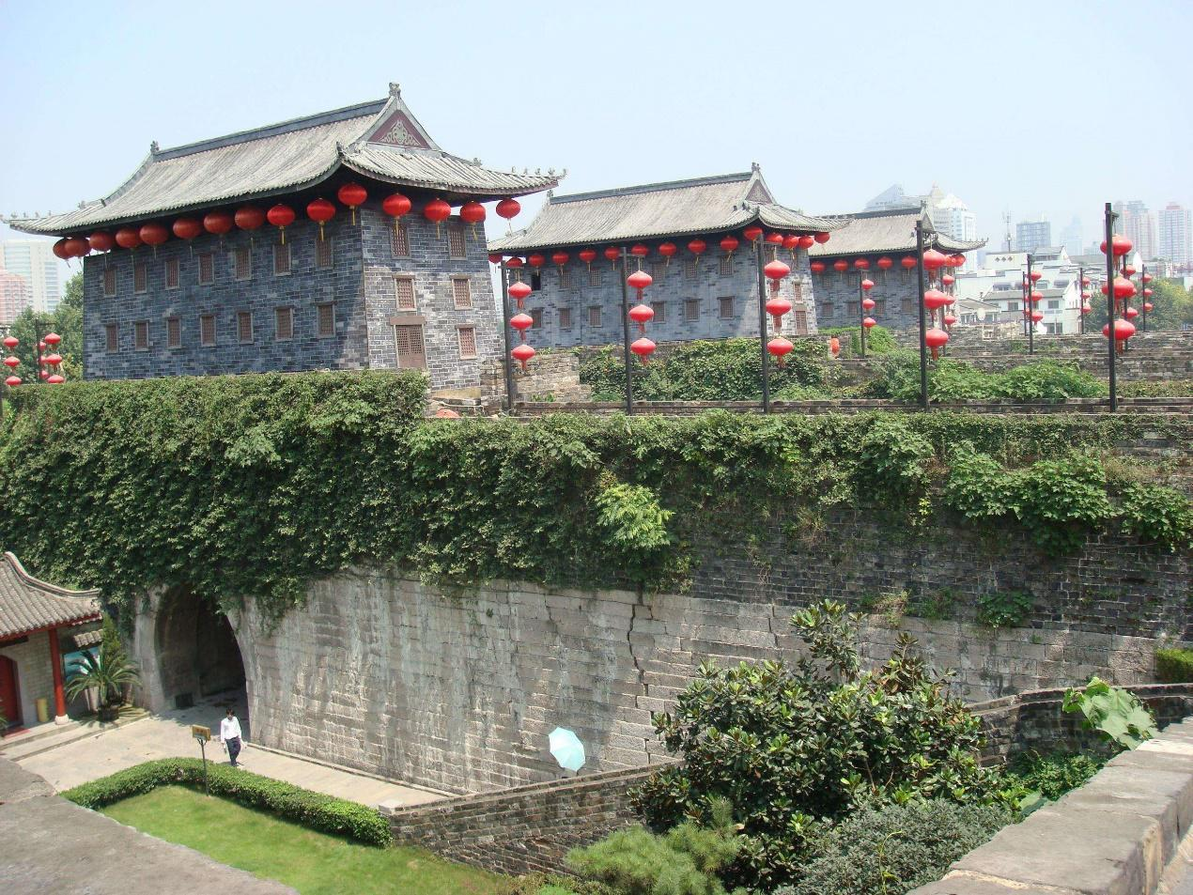

扩建而成，称聚宝

门。1931 年（民国

二十年）国民政府

改名为中华门。

Once serving as

the south city

gate of capital of

South Tang Dynasty (937-975) and accompanying capital of South Song Dynasty (1127-1279), the existing Zhonghua Gate was expanded during 1369-1375. The gate was named as Jubao Gate (the gate of treasure) at that time, as it was believed that here buries the treasure pot of the ancient Billionaire, Shen Wansan. In the year of 1931, after the Republic of China government established Nanjing as its capital, the gate was renamed Zhonghua Gate (the Gate of China).

老门东位于中华门以东，因地处南京京城南门（即中华门）以东，故称“门东”。明朝中华门与内秦淮河沿线成为城市的经济中心，老门东成为重要的商贸和手工业的集散地，集中体现了南京老城传统民居的风貌。老门东小吃街汇集了蒋有记、鸡鸣汤包等老字号，蓝老大糖藕粥、徐家鸭子、司记豆腐脑等南京美食，还有夫子庙名小吃等。
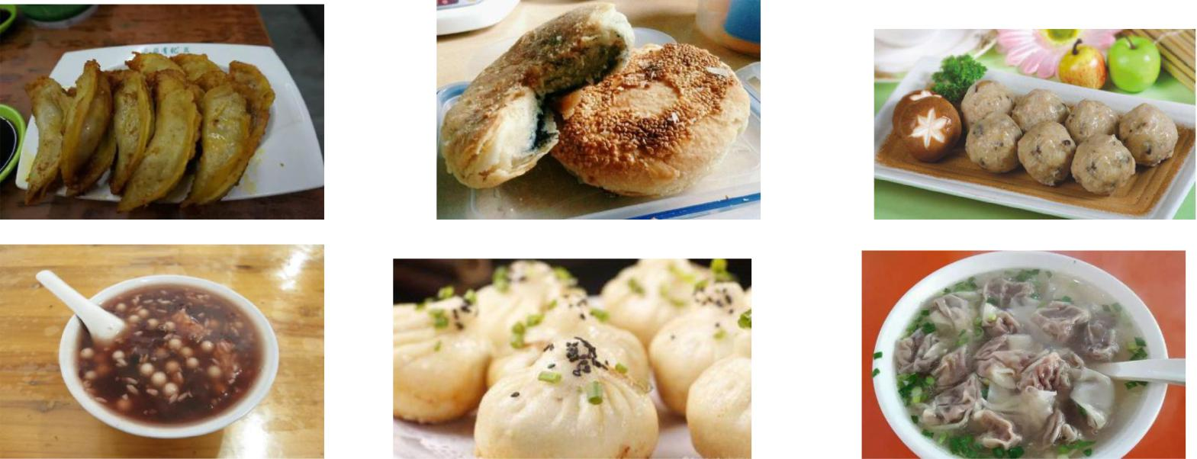

Laomen Dong is the urban area located on the east of Zhonghua Gate. It is named after its location. As the center of the city, Laomen Dong is assembly point of handicraftsmen and merchants. The building here also is representative of typical folk house of the regions south of the Yangtze river. The street of snacks here gathered traditional juicy dumplings, sweet lotus root with Osmanthus fragrant, tender tofu, etc.

